FEDERAL STATE AUTONOMOUS EDUCATIONAL INSTITUTION OF HIGHER EDUCATION
"NATIONAL RESEARCH UNIVERSITY
"HIGHER SCHOOL OF ECONOMICS”

St. Petersburg School of Social Sciences
Sukhareva Elizaveta Sergeevna
Factors Encouraging U.S. Governors To Deviate From The Party Agenda
In Public Speeches

Final qualifying paper

in the field of training 41.03.04 "Political Science"

student of the group 212 (educational program "Political Science and World Politics" / "Political Science")
Scientific supervisor
Associate professor
Shevtsova Irina Konstantinovna

Saint-Petersburg 2025

Annotation
American governors occupy a unique power position, balancing between the interests of the party and local voters. However, party discipline among the U.S. executive authorities remains understudied. This work aims to identify factors influencing the degree of commitment of U.S. governors to the party agenda in public speeches; both structural conditions and personal characteristics of the officials are considered. Adherence to the party agenda is understood as the similarity of the governors’ public speeches with the program of the party to which they belong. Methodologically, I rely on text analysis, regression analysis and further exploration of outliers to answer the research question: “Which factors encourage governors to shift from the party agenda in their public speeches?”. As a result, structural variables are more statistically significant than individual-level factors: high governor’s Approval rating is associated with a greater similarity of their speech with the party program, and the governors of richer states deviate more from the party agenda. Party affiliation is also an influential factor: Republicans are less partisan than Democrats.

Аннотация
Американские губернаторы, являясь значимыми акторами на политической сцене, занимают положение, балансирующие одновременно между продвижением интересов партии и локальных избирателей. Однако, в отличие от широко изученных законодательных органов, тема партийной дисциплины в рядах губернаторов остаётся недоисследованной. Данная работа нацелена на выявление факторов, влияющих на степень приверженности губернаторов США партийной повестке в публичных речах. К факторам я отношу как структурные условия, в рамках которых действует губернатор, так и персональные характеристики политиков. Степень следования партийной повестки в данном исследовании понимается как схожесть публичных речей губернатора с программой партии, к которой он принадлежит. Методологически я опираюсь на метод текстового анализа, регрессионный анализ и дальнейшее изучение выбросов, чтобы ответить на исследовательский вопрос: «Какие факторы побуждают губернаторов отходить от партийной повестки в своих публичных выступлениях?». По итогу структурные переменные оказываются более значимыми, чем агентурные факторы: высокий рейтинг одобрения губернатора связан с большей схожестью его речи с партийной программой, тогда как губернаторы более богатых штатов сильнее отклоняются от партийной повестки в публичных речах. Также влиятельным фактором является партийная принадлежность губернатора: республиканцы оказываются менее партийными, чем демократы.

Heading
Introduction 4
1. State of the Art 7
1.1 Between Strength and Resistance: The Multifaceted Power of U.S. Governors 7
1.2 Party discipline 9
1.3 Public speeches as a weapon of informal power 14
2. Theoretical framework 17
2.1 Structural factors affecting party discipline 17
2.2 Individual-level factors affecting party discipline 20
2.3 Partisanship and its implications for the alignment with party narrative 21
3. Methodology and data 22
3.1 Dependent variable 23
3.2 Independent variables 24
3.3 Control variables 25
4. Data analysis 26
4.1 Regression Models with Party Affiliation as a Dummy Variable 26
4.2 Rethinking Partisan Discipline: Republicans vs. Democrats 29
4.3 The Role of Structural Factors: Approval and Economic situation 30
4.4 Bureaucratic Background and Party Alignment 30
4.5 Analysis of Outliers 31
4.6 Within-party models for republicans and democrats 33
4.6.1 Republican governors 34
4.6.2 Democratic governors 36
Conclusion 38
Bibliography 40

Introduction
As is widely acknowledged, the American political system is characterized by a marked degree of decentralization. This inherent feature of American federalism predetermines and explains a substantial measure of autonomy in decision-making and agenda-setting of American politicians. However, the strength of decentralization in the United States is matched by the strength of partisanship: the two-party system is integral to American politics.

This intriguing interplay creates a unique context for political actors, particularly state governors. On the one hand, being elected from a particular party, governors inevitably find themselves bound to its discursive practices and are forced to take into account the party's agenda when forming public statements and making decisions. On the other hand, governors are defenders of their voters’ local interests and can prioritize issues that matter to the population over those promoted by the central party leadership, particularly in view of the lack of strict disciplinary measures.

This dual role forces governors to constantly balance between adhering to the party line and responding to the specific demands of their electorates. My research seeks to explain the conditions under which American governors deviate from established party agenda in their public speeches, using their annual State of the State addresses as empirical material.

There is a debate in the academic literature on the U.S. political system: some authors argue that party affiliation no longer plays a significant role, whereas other researchers claim that partisanship is still an important argument influencing politicians’ behaviour. This topic is scientifically relevant in the context of growing interest in political polarization and party discipline, especially in today’s turbulent times when even a robust American political system seems to be unstable.

While party cohesion is often studied through legislative voting behavior, less is known about how elected executives, particularly governors, promote party values in their public speeches. Moreover, the issue of party discipline is usually considered in the context of parliamentary democracies, while in a presidential democracy, which is the United States, it seems to be not so acute, especially given the fact that there are no anti-defection laws in the U.S.

Nevertheless , every prominent politician identifies himself with a particular party, and as it will be shown further, governors have enough incentives to adhere to the party's agenda, and the opportunity to move up the career ladder and maintain access to party resources are the key of them.

I started by saying that the U.S. political system is decentralized, and relations within the party are no exception. The pattern of alignment with the party line cannot be generalized as there are outliers diverging from the official party agenda: (a) governors who do not adhere to the party agenda; (b) governors who discuss a topic usually speculated by the opposite party in more detail.

One of the last bright manifestations of such inner-party decentralization was the COVID-19 pandemic, when governors gained a wide degree of independence, according to the 10th Amendment of the U.S. Constitution. In the face of an uncoordinated federal response, it was the governors who became the main decision makers, which often forced them to go against the party agenda.

These findings set the direction for the present research, stimulating exploration of what motivates governors to deviate from the party agenda. I can define the lack of complex studies analyzing the degree of deviation of governors from the party agenda and the incentives for such deviations, both structural and agency, as a research gap in the current academic topic. This study contributes to this emerging field by combining text analysis with regression analysis to identify general trends and statistically significant predictors, and supplements the investigation with an outlier analysis to examine illustrative deviations in depth.

From here, the research question is formulated as follows: Which factors encourage governors to shift from the party agenda in their public speeches?

The goal of this research is to identify which factors, and to what extent, influence the degree of similarity between governors’ public addresses and their party agenda.

To achieve this goal, this research sets the following objectives:
- to review and analyze a block of literature on the topic of party discipline and to relate it to the context of the United States and American governors’ scope of powers;
- to formulate theoretical expectations based on the existing theories, empirical patterns identified in previous studies and peculiarities of American gubernatorial politics;
- to operationalize ideological alignment between governors and party agenda using text analysis (cosine similarity);
- to test hypotheses using multiple linear regressions;
- to interpret results through both general patterns and selected outlier cases.

The theoretical framework combines observations from Principal-Agent Theory, Responsible Party Government Theory, and Office-Seeking Theory, allowing to analyse the influence of both structural factors and individual-level incentives on political behaviour manifested in public speeches. Special attention is paid to the organizational differences between the Democratic and Republican parties.

The core of the empirical analysis is based on multiple linear regression, using cosine similarity between governors’ speeches and party platforms as the dependent variable. Two independent variables are Governors’ Approval Rating and state-level GDP, and control variables include age, gender, and professional background of each governor. The model also incorporates a time lag, linking speeches from 2019 to 2021 to predictors from 2018 to 2020, reflecting the timing of State of the State addresses. In addition to the quantitative analysis, some outliers are examined qualitatively to deepen individual cases of deviation.

The structure of this study includes 5 sections. Chapter 1 provides a review of the existing literature, structured around three key themes: an overview of the powers and responsibilities of American governors, an examination of party discipline with a focus on the factors that shape it, and an analysis of public speeches as a tool of informal gubernatorial influence. Chapter 2 introduces the theoretical framework and formulates the main hypotheses and expectations. Chapter 3 describes the research design, including data collection and methodological approaches. Chapter 4 presents the findings of the empirical analysis and offers an in-depth discussion of the results. Finally, the conclusion summarizes the key insights and situates them within the broader academic context .

1. State of the Art

Named by Kousser and Phillips as “the central figures of state politics” governors play a key role on the American political scene. Some researchers even claim that the expectations from governors often exceed their constitutional authority by stating that these officials , chosen directly by citizens, seem to be the closest to the population in terms of political accountability. However, ordinary electorate often overlook “the mismatch between these expectations and the constitutional authority of the executive”. Nevertheless, this observation does not negate the fact that the authority of American governors is large and penetrates into many areas of public life. The first introductory section of this literature review will be devoted to the powers of American governors in order to realize the scope of their real authority.

1.1 Between Strength and Resistance: The Multifaceted Power of U.S. Governors

Scholars consider the powerfulness of American governors through exercising their authority in various dimensions of the state’s policy: “head of the executive branch, chief legislator, unofficial head of the state political party, and head of the state militia (National Guard) in times of crisis”. There is the scope of literature stressing the governor's important role in implementation of social policy: from healthcare — governors apply executive orders that directly impact public health — to education — governors appoint commissions and control the development of an approach to the implementation of common educational standards in their states. According to the literature, Their leadership has manifested itself especially prominent during crises, for instance, the U.S. states’ response to COVID-19 varied significantly. Moreover, according to recent research, political-regional differentiation has a tendency to increase.

Another crucial dimension of governors’ activity is the fiscal sphere. Scholars concur on the importance of this aspect in strengthening the authority of the governors: they control the budget of the state playing a crucial role in its development and approval which, in turn, gives them the opportunity to influence the allocation of resources and prioritizing of public policy decisions. Thus, based on the literature, governors are considered to shape the economic development strategies of the states.

Kousser and Phillips in their work pay a lot attention to the financial component of governors’ work: declaring in the name of their book the statement “Winning on Budgets and Losing on Policy” they highlight the importance of the fiscal field for these politicians. Another significant aspect of their book is the declaration that despite the vast volume of power in social and budgetary fields, governors can face difficulties in implementing their policy initiatives. Officials can encounter resistance from the legislature or from the public promoting their policy proposals. This argument about the fiscal power and legislative weakness of governors is supported by other scholars. In two words, these studies assert that the problem with the legislative branch of power and citizens can be solved using informal tools “to counteract their [governors’] formal weakness”.

Indeed, the scientific community stresses that governors have a variety of informal carrot and stick tools which, if used wisely, can force legislatures to cooperate. Scholars highlight political connections, public support, and negotiation skills as key informal resources of governors. Living experience and professional background is also reviewed as a factor enhancing a governor's ability to affect state administrative agencies: using personal relationships and linkages governors can build connections with legislative leaders engaging them in strategic communication. Thus, a huge volume of informal instruments translate governors’ formal authority into actual influence, and a combination of both formal and informal assets is essential for effective gubernatorial leadership.

Another possible obstacle for governors in implementation of their agenda is the resistance within their own party. This factor is more complex and difficult to overcome: the debates about the influence of partisanship on the behavior of governors are still actual. Party discipline is the focus of the next section of this literature review.

1.2 Party discipline

The review on this topic is started from the observation of worldwide patterns affecting the party discipline. Five major factors were identified during the analysis. The first one is party ideology — mostly mentioned in the literature devoted to Latin American countries and highlighting that legislators from left-wing parties are more party-disciplined than those from right-wing parties.

Party affiliation is an important anchor shaping the behavior of American political actors. Even despite the fact that the American political system is very decentralized, bipartisanship is inseparable from American public policy, and my further analysis will take into account the party affiliation of the governor as a factor influencing his behavior.

The second factor is the electoral system also potentially influencing party discipline. For instance, in the Lithuanian Seim deputies from single-seat constituencies are more disciplined than deputies on party lists. It was found out that mixed electoral systems, such as Italian, create incentives to enhance party discipline. For my study I do not take this factor as I work with governors who are elected directly by the citizens.

The third factor is more relevant for my research, and it touches on the personal background of the politicians. In the previous block it was mentioned that the background is a crucial factor enhancing informal tools in the governors’ arsenal. Moreover, it also affects the degree of their independence and strength, including the ability to violate the party discipline. An interesting conclusion was made about the Russian deputies with previous executive business positions who turned out to be more prone to defect from party lines. For the Romanian case it was also found out that previous leadership positions were strong predictors of their support for increased party discipline. American governors are people with diversified professional backgrounds: from educators to businessmen and state servicers. Based on this diversity, it would be interesting to study the influence of the governor's previous work experience on the degree of deviation from the party agenda during public appearances.

The fourth factor affecting party discipline is gender. Studies analyzing this aspect are presented for many systems around the world: scholars explored the state of affairs in Canada, African countries, Nordic countries and many others. Most researchers say that women are more party-disciplined than their male party fellows, but it all depends on the context of a particular country. Male American governors prevail over female colleagues: in my sample only 18% of governors are women. Therefore, it is interesting to see whether the gender factor is significant in the governor's decision to deviate from the party narrative.

The fifth factor refers to the institutional rules within the reviewed political system. Obviously, the legal framework in which politicians operate, as well as the range of their powers determining the degree of their freedom, will greatly influence the level of party discipline. In the literature it is claimed that strict party discipline is often enforced through institutional mechanisms. For instance, in India anti-defection laws penalizing legislators for voting against party lines are implemented. The same mechanism is used in Israel aiming to prevent party switching and ensure legislative stability.

Institutional rules also influence party discipline by establishing behavioral norms that politicians seem to follow. In the UK House of Commons consensus on these norms favours a stable party discipline among MPs. In the U.S. there are no strictly proclaimed anti-defections laws like in India or Israel. Moreover, according to the Constitution and electoral system, politicians are given greater individual autonomy making institutional rules more flexible than in the UK. For this reason, I will not review this factor for quantitative analysis.

In the previous section we discover that American governors are endowed with a significant range of institutional authorities and, according to legal norms, have a large degree of freedom for their actions. Below I would like to deal with peculiarities of the American political system in the issue of party discipline.

Most articles on party discipline in the United States focus on the Congress analyzing the influence of this phenomena on the legislative processes. Scholars also review party discipline in the context of the incentives through which party leaders gain loyalty and discuss current challenges of a partisanship control. There are also comparative studies or temporal studies, but the absolute majority of them concentrate on the legislative branch's activity. Thus, the executive body, represented by governors, remains outside the research observation.

As it was mentioned before, there are debates about the role of partisanship in determination the authorities’ political behaviour. “Political parties within the states become at times but the shadow of their national counterparts” — that was what Key wrote about states’ partisanship in 1956. In the 1960s, Democratic and Republican Governors Associations were formed, and the role of these organizations was to promote the interests of Democratic and Republican governors. State party organizations grew stronger in the 1960s and 1970s, but discussions about the role of the party in individual politicians’ behaviour have been going on since that time and still today. Some authors since 1980-s have said about the decline of parties in American politics. Wilson and Dilulio in their work in 1995 claimed that “voters no longer strongly identify with one of the major parties as they once did", as well as that "the two major parties are no longer as central as they once were". However, times have changed, and now another group of authors assume that comments regarding the decline of parties are outdated.

Taking into account the ambiguity in assessing the influence of partisanship on the behavior of political actors and the absence of anti-defection laws in the USA, one might wonder: Do governors generally need to demonstrate support for their native party in word or deed? What kind of sanctions or benefits are given for rejecting or adhering to the party's agenda? The literature on the topic tends to suggest that it is more beneficial for governors to manifest partisanship adhering to the rules of the game, highlighting career prospects and access to party resources as the main incentives for politicians to comply with the party line.

Fundraising is becoming more and more important in political campaigns, therefore, money has become crucial. Any politician needs to establish good relations with the party if they want the party committees to allocate funds for their electoral campaign.

The party's support also promises career prospects at the federal level: for example, governors who clearly follow the ideological line of the party are perceived as loyal candidates for promotion, for example, to federal posts. Governors, as linkers between the local and national party center, must remember about their partisanship if they have ambitions beyond the governorship.

As Donald notes, the post of governor is often perceived as “highly transitor”: the governorship serves as a significant step in advancing political careers providing unique opportunities for visibility. Thus, ideological alignment of governors influences their political longevity as the party leaders encourage compliant members with opportunities to advance their own political careers. Loyal governors usually receive benefits “in the form of help with their own bills, committee positions, or campaign dollars” — all this in conjunction with attendant publicity increases governors’ chances of re-election. “When political recruiters search for attractive candidates they look where they have found them before” — if the governors demonstrate their loyalty to the party, it will make them more attractive candidates for recruiters.

Gubernatorial role has always been considered as a unique position balancing between the federal party apparatus and local voters. Jensen wrote about “dual gubernatorial responsibilities” for the promotion of both state interests and the interests of the party. Recent research suggests that today there is a greater emphasis on party interests. Going into this in more detail, the governor's responsibilities include managing interactions with the federal government, local governments, and with other states — in this relationship, the governor needs to defend the state's interests. Moreover, as chief executives, governors traditionally represent state interests in Washington. On the other hand governors must also manage concerns of partisanship: all but a few independent governors are their party’s de facto leaders. Ties to the party are strong, and it is in governors’ interests to strengthen coalitions with their party elites at the federal level.

Summing up, governors have a special status marked with their ambivalent authorities. The U.S. political system binds the governor to both the party and the state, and sometimes these interests may coincide, but in other cases they may be opposite. To promote such interests politicians mostly use public appearances. The next section of the literature review is devoted to public speeches and factors prompting the governor to deviate from the party's agenda.

1.3 Public speeches as a weapon of informal power

The best way to demonstrate authority, highlight achievements and hide shortcomings for the politicians is through public appearances. Governors design their public speeches in different ways, and the choice of issues covered is the theme for many studies. There are many studies analyzing public statements of politicians for many political systems around the world: Germany, United Kingdom and Nigeria. In two words, such literature draws conclusions that political leaders constantly monitor public opinion and respond to citizens' priority issues. Thus, the formulation of the agenda is a bottom—up rather than a top-down process, and politicians' speeches are carefully thought-out acts of communication aimed at legitimizing power and masking negative outcomes.

For the USA, the focus of research is mainly on the national level, not subnational one: speeches by Presidents or Congressional members usually become the subject of analysis when governors still receive a few attention in the research agenda. The analysis of the gubernatorial performances is present, but it is oriented on an attempt to analyze either only structural factors — governors’ response for the electorate preferences and the economic condition in the state — or only agent-based factors — religion, gender or personal aspirations. Thus, in the American context, the issue of gubernatorial public addresses is poorly studied, especially in the context of a comprehensive analysis of both structural and individual factors.

To conclude, American governors are important actors on the U.S. domestic political arena. Taking into account some difficulties in implementation of the legislative agenda, literature on this topic draws a conclusion about the importance of informal resources for governors' activity. Gubernatorial popularity, being influenced by economic conditions, political factors and personal politician’s characteristics, affects public support and boosts the success to promote a certain policy.

Being in a unique managing position, governors must maintain a balance between party and state, between ‘federal’ and ‘local’, between Washington and the electorate. Nevertheless, in any case, stepping away from the party platform comes at a price. Researches state that the deviation from the party agenda is a risky maneuver for politicians entailing a possible decline in their popularity. Thus, the shift from the party narrative is not a widespread choice for American governors, however, some of them pursue this strategy. There is no detailed explanation for the American governors' deviation from the party line in the academic literature. I can define the lack of complex studies analyzing both structural and individual-level factors influencing the party discipline among governors as a research gap in the academic field. Moreover, studies that check the degree of deviation of governors from the party agenda and analyze the incentives for such deviations are scarce. My research, combining these two components, fills the identified gap.

2. Theoretical framework

2.1 Structural factors affecting party discipline

Answering the question about the reasons that encourage governors to deviate from the party agenda, I can refer to Principal-Agent Theory: this model claims that some actor “called an agent undertakes an action on behalf of another actor called a principal” and suggests that agents “need not in fact be perfect agents of their principals”. Actors have information asymmetry in their relationships, and agents usually are more informed and can be incentivized to act in their own interests, rather than in the interests of the principal. In this research, governors, the agents, strive to achieve re-election, make good policy, and build a reputation of historical achievement. Therefore, they may deviate from the preferences of their party, a principal, to align themselves with the broader interests of their constituents to ensure political longevity.

On the other hand, the Responsible Party Government Theory explains the importance of commitment to the party agenda stressing the central role of partisanship in ensuring the work of the American government. However, this model often fails in explaining gubernatorial behavior in the US, mainly because of the Divided government theory describing a political situation when different parties control different branches of power. This phenomenon is widespread in the U.S., and it clarifies why governors choose the strategy to deviate from party agenda: if the governor belongs to one party and the state parliament is controlled by another one, he will try to gain the support of both sides in order to promote his legislative initiatives. Therefore, his rhetoric can be softened so as not to alienate members of the opposition party in the legislative assembly.

Voters can reward or punish incumbent governors on the basis of state economic performance. The Theory of fiscal federalism examines the distribution of financial resources between different levels of government: local governance, according to the theory, should be responsible for the provision of local public goods as it is more responsive to citizens knowing their needs and preferences.

Recents studies in this field demonstrate closer attention to political processes and the behavior of political agents: overlapping with Principal-Agent Theory assumptions, the Second-Generation Theory (SGT) of Fiscal Federalism assumes that political actors have their own interests which they try to maximize in the process of making economic policies. Taking into account the vast authority of American governors in the budgetary field and based on SGT conclusions, the financial independence of the region can be considered as a key factor for its political independence. Therefore, states with strong economies have more opportunities to be politically independent from the center and afford to deviate from party narratives.

As it was mentioned before, governors possess a huge volume of informal powers, and their popularity affects the success to promote a certain policy. Popular governors are more likely to have success in implementing their agenda and proposing ambitious policies to leverage their popularity. In the framework of the existing topic, it can be assumed that this “ambitious” policy can go beyond strict party narratives causing gubernatorial deviation from them.

Going beyond the party narrative is also explained by Office Seeking Theory, according to which the main goal of a political party or politician is to consolidate and retain power. To achieve these goals and gain a foothold on the political arena, politicians can publicly take credit for certain political achievements attractive for voters in line with Mayhew’s concept of “credit-claiming”. According to Mayhew, it is one of the three ways in which politicians seek re-election (along with position taking и advertising). Based on this concept, it is reasonable to suppose that popular governors with higher approval ratings can claim more pretentious credits and make louder statements going beyond the party agenda. In light of these assumptions the following is anticipated: the higher the governor's approval, the more freedom they have to say something outside the party line.

From the other side, referring to Accountability theory, effective governance requires elected officials to remain accountable to the public they serve. Theoretical works outline the link “between formal accountability, responsiveness of incumbents to voters, and voter welfare”. Thus, public officials seek to maintain voter support, which requires them to operate within predictable frameworks of behavior. One of the strategies can be, for example, following the party line in order to preserve political legitimacy. Therefore, governors with high approval ratings may be inclined to strengthen their reputation by demonstrating party loyalty, confirming that they are reliable and stable representatives of the political force.

Moreover, the above mentioned Office Seeking Theory can also be viewed from another angle: in order to secure a place in office, politicians demonstrate an adherence to party agenda, minimizing deviation risks that could erode support from both the party establishment and the electoral base. Thus, governors with high support receive an incentive to continue following the party line as a proven means of achieving success and demonstrating predictability. Therefore, another expectation can be formulated: the higher the governor's approval, the more they adhere to the party line in order to avoid breaking their established formula for success.
Based on the aforementioned theories, the following hypotheses are formulated.
Two mutually exclusive hypotheses regarding governors’ approval ratings are proposed:
Hypothesis 1a: U.S. governors with higher levels of executive approval will deviate more from the party agenda in their public speeches.
Hypothesis 1b: U.S. governors with higher levels of executive approval will deviate less from the party agenda in their public speeches.
Hypothesis 2: Governors of U.S. states with stronger economies will deviate more from the party agenda in their public speeches.

2.2 Individual-level factors affecting party discipline

However, not only institutional factors like economic condition or approval rating affect governors’ strategies. As noted by Putnam, elite behavior can be fully understood only taking into account both structural and personal characteristics.

One such individual-level factor listed as an affecting party discipline in the second block of the literature review, is the governor's professional background influencing politician’s status and connections with the “right” people. An abundance of connections stemming from the governor's experience increases the amount of his informal power, which, as scholars stress, is an important tool for exercising authority. Thus, it would be valuable to examine whether a relationship exists between a governor's professional background and the extent of deviation in their public speeches from the party agenda.

The next factor is the gender of the governor. As can be seen from the literature review, most scholars come to the conclusion that women are more party-disciplined. Thus, the expectation that U.S. male governors will deviate more from the party agenda in their public speeches will be tested further in the analysis.

Age of a politician can be associated with political experience, conservatism, or, conversely, with independence. Senior politicians can either strictly follow the party line, or vice versa — act more autonomously due to authority.

2.3 Partisanship and its implications for the alignment with party narrative

Speaking of partisanship, the Democratic Party itself is more diverse and heterogeneous in comparison with the Republican Party. As Grossmann and Hopkins stated in their book: “...the Democratic side is composed of a more diverse and complex coalition of actors whose affiliation with the party is mediated by a variety of specific interests and identities”. This book reflects a point of view also circulating in the public political discourse of the United States: Democratic officials, unlike their Republican colleagues, rarely try to satisfy the demands of their party base.

Republicans are more likely to declare their devotion to eternal ideological truths, whereas Democrats demonstrate sensitivity to the specific problems of individual party elements (trade unions, minorities, environmentalists, etc.). Thus, the Democratic Party is formed as a coalition of social groups whose differences combine to create a collective political platform. And the Republicans are the modern conservative movement, where most officials agree with a common set of key ideological principles. Perhaps such fragmentation and variability of the Democratic party may reduce the level of similarity of the governors' public speeches with the party program. Overall, I expect Republicans to be more committed to the party's agenda than Democrats.

In general, the theories and expectations outlined above provide solid foundations for further analysis, simultaneously, leaving room for interpretation and new conclusions.

3. Methodology and data

To examine how the degree of similarity of the public speeches of governors with the party agenda might be related to Governors’ Approval rating (Hypotheses 1a/ Hypothesis 1b) and GDP per state (Hypothesis 2) I employ regression analysis. Specifically, multiple linear regression was chosen as the most appropriate method to assess the simultaneous influence of several independent variables. Preliminary, text analysis will be employed to prepare the Dependent Variable.

Multiple linear regression is a quantitative analytical method simultaneously assessing the collective influence of multiple independent variables on a single dependent variable; it is widely used in social sciences, including political science. The main task of multiple regression is to identify which factors and to what extent are associated with changes in the dependent variable upon condition that all other variables included in the model are controlled.

Choosing from the alternative methods, logistic regression is not suitable owing to the continuous nature of the dependent variable. Multilevel regression cannot be used effectively because of the small number of observations (143) and the presence of only 50 unique groups (U.S. states). Thus, multiple linear regression seems to be the most reliable and interpretable choice for this study.

Models with the analysis of only structural factors can show biased estimates, and to avoid such a misrepresentation, I control for several individual characteristics: gender, age and professional background of governors.

To test the hypotheses a general regression model with partisanship as dummy-variable will be built in the first part of the analysis. This type of model helps to determine whether there is a statistically significant difference between Democrats and Republicans in their degree of similarity to the party program. In the second part. separate models for each party will be built to check if the selected factors operate equally within each party. Before building regressions, all models were checked for multicollinearity to ensure reliability of them (Appendix 1).

After building the models and interpreting results, an analysis of the outliers will also be performed to identify features of individual observations that cannot be explained using a general model.

3.1 Dependent variable

To operationalize the degree of alignment of gubernatorial speeches to the party program I calculate the similarity between governors’ State of the State addresses with Party Programs. I used a ready-made database containing speeches of U.S. governors from 1995 to 2022. For my study, a sample representing 143 "State of the state" addresses for 3 years, from 2019 to 2021, was taken. This time frame was chosen due to limitations in one of the Independent variables, which will be explained below. ‘State of the state addresses’ are the official addresses of American governors about the state of affairs in their region. Seven states were excluded from the analysis in 3 years (143 instead of 150): this is due to the fact that in Ohio (2021, 2020), Montana (2020), Nevada (2020), North Carolina (2020), Oregon (2020) and Texas (2020), public appeals were canceled due to complications related to the COVID-19 pandemic. These 143 addresses form the basis for the calculation of my dependent variable.

An important peculiarity is that the speeches of the governors are taken for the year following the year for which the independent variables are viewed. Thus, ‘approval’ and ‘gdp’ for 2020 will correspond ‘cos_similarity’ for 2021, ‘approval’ and ‘gdp’ for 2019 — ‘cos_similarity’ for 2020, and ‘approval’ and ‘gdp’ for 2018 — ‘cos_similarity’ for 2019 respectively. It is attributed to the fact that State of the State addresses are traditionally pronounced in January, based on the state's results for the past year and declaring goals for the future. Figures for independent variables (Approval Rating and the size of GDP), on the contrary, are collected at the very end of the year. Accordingly, the speeches from the subsequent year serve as a relevant basis for assessing the influence of the prior year’s variables on them.

The dependent variable is the degree of similarity between the party's agenda of the Republican and Democratic party with each State of the state address separately. I operationalize this measure through calculations using the package “lsa” which is intended for natural language processing (NLP) and text data analysis. One of the package's functions is to calculate the cosine similarity between documents or terms to assess their semantic similarity, which was done using the measure 'cosine similarity’. Mathematically, it calculates the cosine of the angle between two vectors projected in a multi-dimensional space regardless of their size. The scale ranges from 0 to 1, with 0 representing no similarity and 1 representing a perfect similarity.

In my case, the cosine similarity is calculated between the Democrats' Party Program (metadata was parsed from the official website) with each governor of the Democratic states, and then between the Republicans’ Party Program (metadata was parsed from the official website) with each governor of the Republican states in my sample of the 3 years. In models, the dependent variable has a name ‘cos_similarity’.

3.2 Independent variables

Independent variables are structural and institutional factors, there are two of them in the work.
- ‘approval’ — executive approval of each governor within the state, ‘Executive approval’ covers governance efficacy estimated by people and the leader's popularity. The data is taken from the State Executive Approval Dataset, representing a dataset of gubernatorial approval ratings from 1980 to 2020.
- ‘gdp’ — Gross Domestic Product per state or Gross Regional Product, economic performance of states, the data is taken from the Bureau of Economic Analysis.
These variables are related to the potential motivation of governors to follow or deviate from the party's agenda.

The study examines a three-year period from 2018 to 2020 (2019–2021 for the Dependent Variable). This time period was chosen for reasons of data availability: data on the Approval governors’ rating exists only until 2020. Adding two previous years, 2018 and 2019, allows for the construction of a multi-year dataset with repeated observations across states, although with some missing values due to data availability (e.g., absence of speeches in certain years). The three-year period also helps to compensate for the impact of anomalies in one particular year and increases the reliability of regression results.

3.3 Control variables

Individual-level factors are used as control variables. Age, gender and professional background are included to account for individual characteristics of a particular governor that are not the subject of the main analysis.

The data for these variables were taken from the following resources:
- Ballotpedia and National Governors Association (projects collecting information about U.S. politicians’ biographies)
- States’ and politicians’ official websites.

All individual-level control variables were calculated as dummy variables. The encoding turned out to be as follows:
- The gender variable was encoded as ‘gender_f’ and implies ‘1’ for the female governor and ‘0’ for the male governor;
- the average age of all governors is approximately 60 years old, so the age variable ‘age_60plus’ is encoded as ‘1’ for the age over 60 and ‘0’ for the age under 60;
- to estimate the professional background of governors, their biographies on official websites were examined, then, one word most accurately characterizing the previous activities were added in the data tabel. There are 8 categories in total: business, jurisprudence, education, engineering, civil service, sport, finance and medical practice. Three most common categories were selected as control dummy-variables: 1. ‘bus’ coded as ‘1’ — with the business background and ‘0’ — without business background; 2. ‘law’: ‘1’ with any kind of legal background (attorney, lawyer, prosecutor, and etc.) and ‘0’ without such background; 3. and ‘service’: ‘1’ with any kind of civil service and ‘0’ without such experience.

4. Data analysis

4.1 Regression Models with Party Affiliation as a Dummy Variable
First, a unified regression model was built for both Republicans and Democrats considering party affiliation as a dummy variable to account for partisan differences. After the encoding, ‘1’ indicates affiliation to the Republican Party, and ‘0’ indicates affiliation to the Democratic Party.

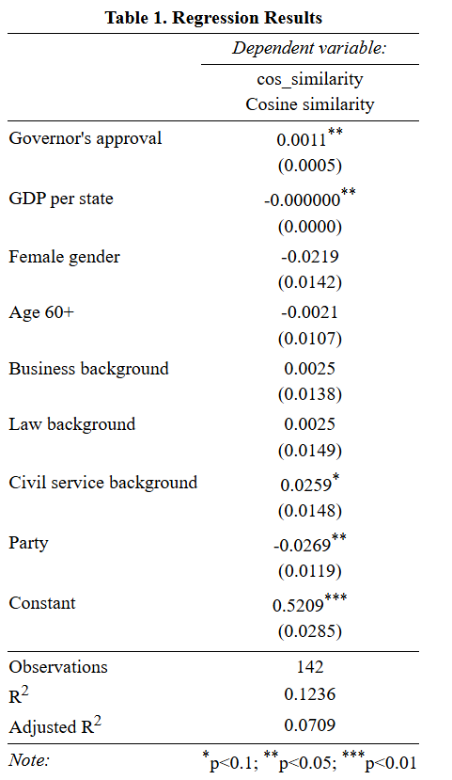
Table 1. Regression results, model with the party affiliation as a dummy-variable (author's calculations)

According to the results (Appendix 2 for the descriptive statistics), three variables are statistically significant: Governors’ approval, GDP per state and partisanship are statistically significant at the 5% level. Civil service background variable is located on the border of significance (p-value =0.0813), consequently, the variable is statistically significant at the 10% level.

- The relationship between DV (Cosine Similarity) and Governor’s approval rating is positive and means that increasing per one unit of the Governor’s approval rating is associated with an increase of 0.00155 of the DV ceteris paribus. It confirms Hypothesis 1b that more popular governors deviate less from the party's agenda.
- The relationship between DV (Cosine Similarity) and GDP per state is negative and means that increasing per one unit of the size of GDP is associated with a decrease of 0.00000002256 of the DV ceteris paribus. The effect is modest, since “1 dollar” is a microscopic unit on the GRP scale. However, GDP is usually measured in millions of dollars, so the effect may be more significant. For example: if the GDP per state increases by $1,000,000, this will result in a decrease in cosine similarity by about 0.02. This confirms Hypothesis 2 that the governors of richer states deviate more from the party agenda.
- The relationship between DV (Cosine Similarity) and Partisanship is negative and means that if the governor is a member of the Republican Party, it is associated with a decrease of 0.02685 of the DV ceteris paribus. This refutes my expectation that Republicans are more committed to the party agenda than Democrats.
- The relationship between DV (Cosine Similarity) and the existence of the background of civil service is positive and means that if the governor occupied a civil service position previously, it is associated with an increase of 0.02593 of the DV ceteris paribus.

The results were visualized with predicted cosine similarity values obtained from the regression model.
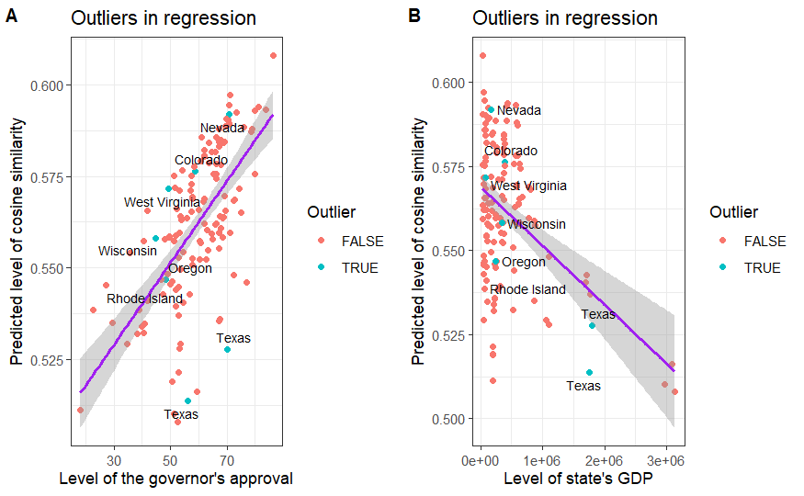
Figure 1. Visualization of the regression model for governor approval ratings (A) and GDP per state (B), including identified outlier (author's calculations)

On both graphs (‘A’ for approval, ‘B’ for GDP), the outliers marked with turquoise dots remain consistent with the overall trend. While they deviate above or below the regression line, none of the dots exhibit patterns that contradict the model's expectations — such as low approval paired with high cosine similarity, or high GDP with high similarity. Thus, the presence of a few outliers does not undermine the general direction of the relationship. For instance, Texas demonstrates lower-than-expected similarity to the party agenda, however, still in the direction of the main pattern of the model. No extreme deviations are observed that would call the effect into question.

4.2 Rethinking Partisan Discipline: Republicans vs. Democrats

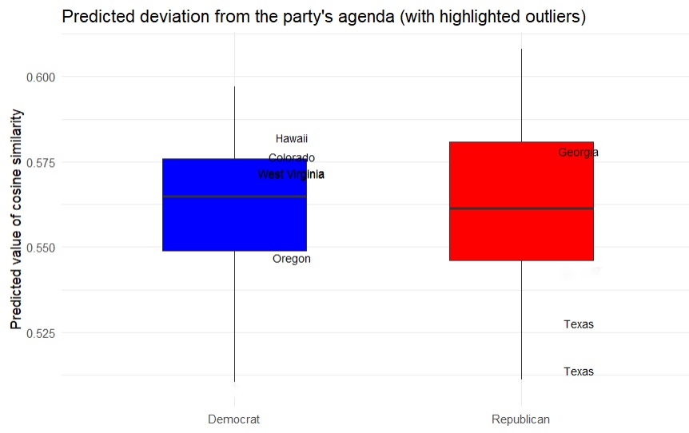
Figure 2. Visualization of the relationship between partisanship and cosine similarity between governors speeches and party program, including identified outlier (author's calculations)
In the graph depicting the relationship between partisanship and cosine similarity between governors’ speeches and the party program (Figure 2), the governor of Oregon in 2019 appears the least aligned with the Democratic Party programm, standing out from the general trend. The governor of Texas in 2019 and 2021 is the least partisan Republican.
An analysis of the model with partisanship as a dummy variable highlighted party affiliation as a statistically significant indicator: according to the model, Republicans demonstrate less similarity to party agenda than Democrats, all other things being equal. Although the difference is small (0.02685), it is present, and this result contradicts the theoretical ideas about a higher level of internal party discipline among Republicans.

Possible reasons for such a result can be the ambiguity of the definition “Party discipline." This term can be conceptualized in different ways, and compliance with the party program in public speeches is just one of the manifestations of party discipline which can be more pronounced in political actions (voting, legislative decisions). Thus, although the quantitative result looks unexpected, it highlights an important area for further research on the strategic communication of governors and encourages a deeper study of the Republican Party. Moreover, regional political (party control over legislative authorities), demographic (life expectancy/ population size), social (proportion of urbanized population, migration flows) or cultural (ethnic composition) characteristics of the state can also significantly influence the behavior strategies of governors.

4.3 The Role of Structural Factors: Approval and Economic situation
The important aspect seems to be that both Independent variables, structural factors, turned out to be statistically significant at the 95% level in the model. This suggests that the behavior strategies of governors, including the decision to follow or not follow the party's agenda in public statements, depend on institutional characteristics to a greater extent than on individual characteristics.
A high level of approval can give governors freedom, but at the same time obliges them to party loyalty in order to maintain popularity. The economic situation (GDP per state) reflects the objective situation — the higher the level of economic well-being, the more independent governors feel during public appearances.
It can be concluded that the institutional environment is more important than individual-level factors. Finally, the crucial factor turns out to be not who the governor is, but in what conditions he operates.
Furthermore, Approval and GDP are indicators of two different dimensions: political and economic. Their simultaneous significance suggests that deviation from the party line is not the result of a personal will, but a response to the complex structural preconditions.

4.4 Bureaucratic Background and Party Alignment

A control variable indicating the presence of civil service background has shown weak statistical significance, which suggests that governors with such experience will stick to the party agenda rather than deviate from it, but this result should be taken into account with caution. The reason is the fact that civil servants entering public politics have socialized in a bureaucratic environment, where they are accustomed to a certain type of behavior associated with strict adherence to the line of the party/ organization/ institution to which they belong. Such governors will forever remain former officials acting within certain norms and expectations requiring caution in public statements. Aberbach and his colleagues comparing bureaucrats and politicians in Western Democracies noted that bureaucrats are more likely to adhere to the status quo: “Ideologically, their consistent centrism leads them to shun radical change <...> Given these traits, policymaking by bureaucrats is likely to be characterized by continuity, stability, and predictability”. That is why governors-former civil servants are less risky and declare what is expected of them according to the party agenda.
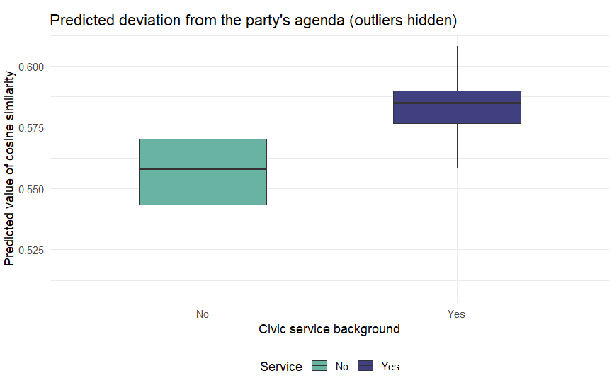
Figure 3. Visualization of the relationship between the presence of civil service background and cosine similarity between governors speeches and party programm (author's calculations)

4.5 Analysis of Outliers
As outlined in the Methodology section, outliers were selected for qualitative illustration to explore cases that diverge from the general model.
According to the results, Oregon is the least partisan among democratic states. There is a list of reasons for such a deviation:
- Democratic political hegemony in the state: in Oregon, the Democratic Party has been in power for 38 years, since 1987 (34 years for the time frame of my research). In such circumstances, it can be not so important for the governor to strictly follow the party line, since voters are likely to support him regardless of the nuances of his rhetoric, but simply because of his alignment to the Democratic party.
- Personal governor’s characteristics: from 2015 to 2023, which is within the scope of my research, Kate Brown was the governor of Oregon. She is known for her political strategy aimed more at cooperation and the search for compromise, rather than strictly following the party's agenda: in one of her official statements, after the Bipartisan Special Session, she thanked lawmakers from both parties for working together, which may indicate her desire for mutual cooperation. One of The New Yorker articles describes Kate Brown as a practical politician, capable of compromise and not seeking radicalization, emphasizing her interactions with various political groups. This reinforces her perception as a political figure prioritizing broad appeal over strong partisan signaling and focusing more on the median voter than mobilizing the party base.
Thus, the combination of the institutional characteristics of the state and the personal characteristics of the governor distinguishes Oregon as an outlier in the corresponding model.

Moving to Republicans, there are several reasons why this state deviates so significantly from the party agenda.
- Political identity of the state: Texas governors usually build a strong personal brand, sometimes basing it on opposition to the federal government. For instance, here is an excerpt from the speech of a memorable Texas governor: “I believe that our federal government has become oppressive in its size, its intrusion into the lives of our citizens, and its interference with the affairs of our state” — here Rick Perry focuses on pressing federal interference in local affairs which indicates Texas’ desire to be more independent. Such statements even provoked a discussion in the media about a possible secession of Texas. Greg Abbott, who is the governor of Texas in the framework of my research, also often focuses on state’s sovereignty rather than the Republican agenda in Washington. He declared March 2, 2022 as Texas Independence Day, and he also signed a resolution asserting Texas sovereignty under the 10th Amendment on all powers not granted to the federal government by the Constitution — these are symbolic acts, but they demonstrate a sustainable defence of local state’s peculiarities and autonomy.
- Local political culture: the value of individualism dominates in Texas political culture. In the book about Texas politics three researchers of The University of Texas at Tyler highlight that state’s political culture as a whole supports individualism: “Texans tend to believe that people, not governments, are responsible for their own well-being and personal achievement”. In addition, most Texans oppose government aid programs and resist state control over businesses like railroads and banks. Therefore, Texas governors will try to follow the ideological views of their electorate by supporting opposition to the central government. It ultimately affects their public speeches and encourages them to deviate from the party agenda.
Finally, in Texas, as in Democratic Oregon, the Republican Party has been in power for more than 30 years, since 1995 (26 years at the time of my research). This fact leads to the beginning of diversification within the Republican Party itself, while at the same time giving the governor sufficient autonomy to deviate from the unified party line, since it simply does not exist in a strictly unified form.
- Significant GRP: on the graph for the variable GDP per state (figure 1), it is seen that Texas is an outlier with a high GDP and a very low level of similarity between the governor's speech and the party program. Thus, Texas' significant GDP reinforces its independence, allowing governors a greater degree of deviation from the party line.

4.6 Within-party models for republicans and democrats

As the next stage of analysis, separate models for Republicans and Democrats were calculated to uncover the most influential factors within each party.

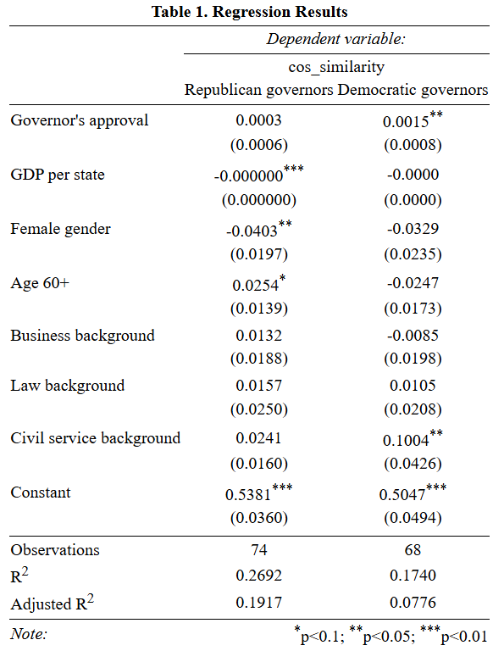
Table 2. Regression results, separate models for Republicans and Democrats (author's calculations)

4.6.1 Republican governors

Based on the model’s results (Appendix 3 for the descriptive statistics), for Republicans GDP per state and gender are significant factors, also outlining age as a weak statistically significant variable.
- The relationship between DV (Cosine Similarity) and GDP per state for republican states is negative and means that increasing per one unit of the size of GDP is associated with a decrease of 0.00000006661 of the DV ceteris paribus. As in the previous model (Figure 1), the effect is modest, since 1 unit in this case is equal to 1 dollar. If the GDP grows by $1,000,000, this will result in a decrease in cosine similarity by about 0.06.
This suggests that Republican governors in richer states deviate more from the party's agenda which is also reinforced by the Texas case descripted above. This variable is statistically significant at the 1% level, and the results confirm the findings of the common model.

- The relationship between DV (Cosine Similarity) and Gender is negative and means that if the republican governor is a woman, it is associated with a decrease of 0.04028 of the DV ceteris paribus. It can be concluded that Republican female governors deviate more from the party agenda. This variable is statistically significant at the 5% level.
This result can be explained by the fact that women in politics may use more flexible, less conflictual, and, consequently, more streamlined rhetoric. Furthermore, they pay much attention to “soft” topics such as healthcare or social sphere, which may be detrimental to compliance with the party line. It leads to discrepancies with party agendas, especially in "hardline" parties like the Republicans.

- The relationship between DV (Cosine Similarity) and Age is positive and means that if the republican governor is older than 60, it is associated with an increase of 0.02536 of the DV ceteris paribus. Thus, older Republican governors are more likely to adhere to the party's agenda. This variable is statistically significant at the 10% level.
Findings may be explained by the sustainable point of view in political science research that people's political views remain relatively stable throughout their lives. At the same time, sociological research is trying to determine the direction of change in such views. Recent studies highlight that when political attitudes do shift across the life span, “liberals are more likely to become conservatives than conservatives are to become liberals.” Thus, if governors do not change their political orientation, they become more partisan at an older age, as they get used to a certain discourse and patterns of behavior. In case they slightly change the political coordinates, it happens in the direction of conservatism, more typical of the Republican Party. This explains the significance of the increase variable for Republicans, albeit at the level of 10%.

Statistically significant variables for Republicans were visualized to demonstrate the results with outliers (Figure 4).
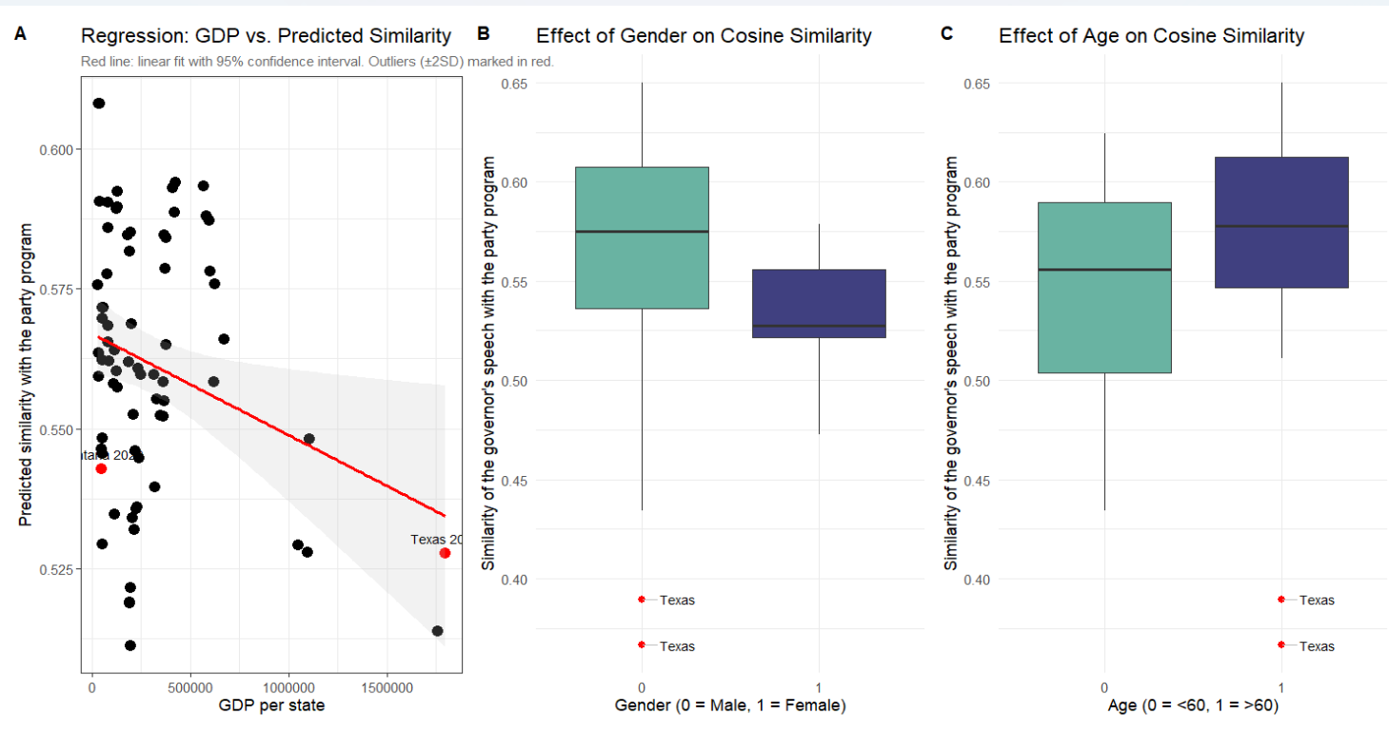
Figure 4. Visualization of the statistically significant variables for the Republican party model (author's calculations)

As in the previous visualization (Figure 1), the outliers do not contradict the general direction of regression, but only slightly deviate from the line without refuting the initial hypothesis. The Texas case was described in detail above.
The initial pooled regression with partisanship as a dummy variable showed a counterintuitive result, indicating that, on average, Republican governors exhibit slightly less alignment with party agenda than Democrats. Models for each party separately add important nuances to this finding.
The regression model for Republican governors proved statistically significant (Table 2, left column).

4.6.2 Democratic governors

For Democrats (Appendix 4 for the descriptive statistics), the approval rating of governors turned out to be a significant variable, and the background of civil service is at the significance level of 10%. However, the model as a whole turned out to be statistically insignificant (p-value = 0.1028 > 0.05), which indicates that there is no sufficient reason to assert that explanatory variables jointly influence the dependent variable. Therefore, the results obtained should be interpreted with caution (Table 2, right column).
Thus, the model for Democratic governors did not yield relevant results. This insignificance may reinforce the theoretical argument about internal party dynamics. As claimed earlier, the Democratic Party operates as a broad coalition of interest groups, which result in wider discursive variation across its officials. This fragmentation can weaken the explanatory power of the regression model because it is difficult to pick up a set of predictors incorporating all the diversity of communication strategies among Democratic governors.
Comparing the results of the two parts of the analysis: the first model (Table 1) takes into account only party membership, without distinguishing between the governors within the party. At the same time, Republicans may have isolated governors who deviate greatly from the norm, for example, as Abbot previously described in Texas. And the Democrats, being more fragmented, may sound heterogeneous, but on average they are closer to the formal party platform. This may explain the fact that, according to the general model, Republicans deviate more from the party agenda, but a separate model (Table 2) turned out to be statistically significant for them. Whereas Democrats as a whole deviated less from the party agenda, but a separate model (Table 2) turned out to be statistically insignificant.

Conclusion
Emphasizing governors’ ambiguous position balancing between the federal center and local voters, this study answered the research question “Which factors encourage governors to shift from the party agenda in their public speeches?”

Drawing upon political science theories related to both institutional constraints and individual-level incentives, and using text analysis and regression analysis as methods, I come to the following conclusions.

First, there is a significant positive relationship between a governor’s approval rating and similarity with the party agenda in public speeches. A higher approval rating is associated with greater alignment with the party agenda in public speeches. This finding supports Hypothesis 1b and disconfirms the mutually exclusive Hypothesis 1a, which posited that higher executive approval grants governors more freedom in public messaging. Given that the governor’s position is often a transitional one on the way to higher federal posts, approval ratings function as a crucial political resource to be re-elected or move further up the career ladder. Voters are likely to evaluate governors associating them with their party. Thus, adherence to the party line increases public approval, otherwise, deviation from the party line may lead to a decline in popularity. In this context, orientation on party programs in public speeches is not only a manifestation of ideological loyalty, but also a tool for maintaining popularity. This conclusion opens different trajectories for further research on how the degree of party support among governors can change during the electoral cycle.

The presence of a negative relationship between the size of GDP per state and the degree of similarity of the governor's public speeches with the party agenda confirms Hypothesis 2 that the governors of richer states feel more free in public speeches, allowing themselves a greater degree of deviation from the party agenda. Such a finding can contribute to further study of the relationship between the economic autonomy of regions and their political independence.

Equally valuable is the insight that models show the statistical significance of both structural factors — governor’s approval and state economic performance; whereas individual-level factors (age, gender and professional background) demonstrate weak statistical significance. Thus, deviation from the party line seems to reflect a strategic response to political and economic conditions rather than personal inclinations.

An assessment of the influence of partisanship on the degree of deviation from the party agenda showed that Republicans deviate more from the party agenda, although the difference with Democrats is modest. This states that partisanship itself is a significant factor influencing the decision of governors to adhere to the party line, however, the results are slightly unexpected.

The variation in interpretations of the term “Party Discipline” can explain such an outcome: adherence to the party line in public speeches serves as just one possible expression of this concept. Deepening the analysis, the Republicans’ less commitment to the party agenda can also be related to the internal party dynamics. The scope of my research includes the first term of Donald Trump's presidency marked by intensified ideological tensions within the Republican Party. Thus, low similarity with the party program can demonstrate a deliberate attempt to distance oneself from strategies of the party center. This supports the broader argument about the decentralization of American politics at both the federal and intraparty levels. The degree of division within the party is quite problematic to assess quantitatively, but it can serve as an influential factor affecting the extent to which the governor deviates from the party agenda in public speeches.

The significance of the party affiliation variable encourages to conduct further examination and build separate models for parties, taking into account not just partisanship in general, but local differences between states and governors within the same party.

The construction of separate models shows ambiguous results: the model for Democrats is insignificant at all, while the Republican one demonstrates relevant outcomes. This fact is explicable by different approaches to party composition: Republicans are traditionally considered as a more homogeneous party, whereas Democrats unites a variety of social groups. Therefore, although Democrats show a slightly greater commitment to the party's agenda in comparison with Republicans, the fragmentation within their party can complicate the identification of stable patterns if the analysis is conducted to estimate the interplay of variables within a single party.
The analysis of outliers has shown that another possible significant factor influencing governors’ behaviour is the length of time the party has been in power in a particular state. Both Oregon and Texas, which are the least partisan Democratic and Republican states respectively, are distinguished by the long (> 25 years) stay of the party in power. Perhaps this creates a certain politically secure environment for the governors, allowing them to feel more independent in public speeches. The party possesses strong authority in such states, and, as a result, governors do not need to brightly emphasize their partisanship in order to gain political capital. This observation opens prospects for future research in this direction. So, it can turn out that the governors of traditionally Republican or Democratic states adhere less to the party agenda than the governors in swing states, where neither Republicans nor Democrats have a stable advantage.

To summarize, the analysis demonstrates significant links between structural factors and the degree of deviation of governors from the party agenda in public speeches. Despite expectations of greater party discipline among Republicans, regression analysis showed opposite results, which are explained by internal party processes. The importance of the approval rating and the state's GDP highlights the influence of the institutional context. The differences between the parties in separate models reflect the different degrees of their homogeneity. These findings contribute to the broader literature on elite political communication and party discipline and emphasize the need for further research of the communication strategies of governors and their interaction with party structures and broader socio-economic context.

Bibliography
- Aberbach, Joel D., Robert D. Putnam, and Bert A. Rockman. Bureaucrats and Politicians in Western Democracies. Harvard University Press, 1981.
- Abramowitz, Alan I., and Steven Webster. “The Rise of Negative Partisanship and the Nationalization of U.S. Elections in the 21st Century.” Electoral Studies 41 (March 1, 2016): 12–22. https://doi.org/10.1016/j.electstud.2015.11.001.
- Alesina, Alberto Francesco, and Howard Rosenthal. “A Theory of Divided Government.” Scholarly Articles, Scholarly Articles, 1996. https://ideas.repec.org//p/hrv/faseco/34222831.html.
- Ashworth, Scott. “Electoral Accountability: Recent Theoretical and Empirical Work.” Annual Review of Political Science 15, no. Volume 15, 2012 (June 15, 2012): 183–201. https://doi.org/10.1146/annurev-polisci-031710-103823.
- Ashworth, Scott, and Ethan Bueno de Mesquita. “Endogenous Party Discipline with Variable Electoral and Legislative Institutions 1,” 2004. https://www.semanticscholar.org/paper/Endogenous-Party-Discipline-with-Variable-Electoral-Ashworth-Mesquita/76e26027468e80f038e04905a508044bf6667b76.
- Baccini, Leonardo, and Abel Brodeur. “Explaining Governors’ Response to the COVID-19 Pandemic in the United States.” American Politics Research 49, no. 2 (March 2021): 215–20. https://doi.org/10.1177/1532673X20973453.
- Barrilleaux, Charles, and Michael Berkman. “Do Governors Matter? Budgeting Rules and the Politics of State Policymaking.” Political Research Quarterly 56, no. 4 (December 2003): 409–17. https://doi.org/10.1177/106591290305600403.
- Bartels, Larry M. “Partisanship and Voting Behavior, 1952-1996.” American Journal of Political Science 44, no. 1 (2000): 35–50. https://doi.org/10.2307/2669291.
- Boeckelman, Keith. “Governors, Economic Theory, and Development Policy.” Economic Development Quarterly : The Journal of American Economic Revitalization, Economic development quarterly : the journal of American economic revitalization. - Thousand Oaks, Calif. : SAGE Publ., ISSN 0891-2424, ZDB-ID 12650857. - Vol. 10.1996, 4, p. 342-351, 10, no. 4 (1996).
- Bovens, Mark, Robert E. Goodin, and Thomas Schillemans. The Oxford Handbook of Public Accountability. OUP Oxford, 2014.
- Budge, Ian, and Michael Laver. “Office Seeking and Policy Pursuit in Coalition Theory.” Legislative Studies Quarterly 11, no. 4 (1986): 485–506. https://doi.org/10.2307/439930.
- Campbell, Angus, Philip E. Converse, Warren E. Miller, and Donald E. Stokes. The American Voter. University of Chicago Press, 1976.
- Castanheira, Micael, and Benoît S. Y. Crutzen. “Comparative Politics with Endogenous Intra-Party Discipline 1,” 2010. https://www.semanticscholar.org/paper/Comparative-Politics-with-Endogenous-Intra-Party-1-Castanheira-Crutzen/6eb3435940b8921441c34f0e7ba36f08a10221a2.
- Clark, Terry D., Žilvinas Martinaitis, and Ramūnas Dilba. “Electoral Mandate and Party Cohesion: Does It Matter in Lithuania?” Journal of Communist Studies and Transition Politics 24, no. 3 (September 2008): 317–37. https://doi.org/10.1080/13523270802267864.
- Clayton, Amanda, and Pär Zetterberg. “Gender and Party Discipline: Evidence from Africa’s Emerging Party Systems.” American Political Science Review 115, no. 3 (August 2021): 869–84. https://doi.org/10.1017/S0003055421000368.
- Coffey, Daniel. “Measuring Gubernatorial Ideology: A Content Analysis of State of the State Speeches.” State Politics & Policy Quarterly 5, no. 1 (April 2005): 88–103. https://doi.org/10.1177/153244000500500105.
- Cohen, Jeffrey E., and James D. King. “Relative Unemployment and Gubernatorial Popularity.” The Journal of Politics 66, no. 4 (November 2004): 1267–82. https://doi.org/10.1111/j.0022-3816.2004.00299.x.
- Cornelis, Ilse, Alain Van Hiel, Arne Roets, and Malgorzata Kossowska. “Age Differences in Conservatism: Evidence on the Mediating Effects of Personality and Cognitive Style.” Journal of Personality 77, no. 1 (February 2009): 51–87. https://doi.org/10.1111/j.1467-6494.2008.00538.x.
- Cox, Gary W. “Comparing Responsible Party Government in the United States and the United Kingdom.” The Journal of Politics 86, no. 1 (January 1, 2024): 67–78. https://doi.org/10.1086/726919.
- Crew, Robert E. Jr., and Gregory R. Weiher. “Gubernatorial Popularity in Three States: A Preliminary Model.” The Social Science Journal 33, no. 1 (March 1, 1996): 39–54. https://doi.org/10.1016/S0362-3319(96)90004-X.
- Crines, Andrew, and Tim Heppell. “Rhetorical Style and Issue Emphasis within the Conference Speeches of UKIP’s Nigel Farage 2010–2014.” British Politics 12, no. 2 (May 1, 2017): 231–49. https://doi.org/10.1057/bp.2016.2.
- Crowe, Edward. “Consensus and Structure in Legislative Norms: Party Discipline in the House of Commons.” The Journal of Politics 45, no. 4 (November 1983): 907–31. https://doi.org/10.2307/2130418.
- Danigelis, Nicholas L., Melissa Hardy, and Stephen J. Cutler. “Population Aging, Intracohort Aging, and Sociopolitical Attitudes.” American Sociological Review, October 1, 2007. https://doi.org/10.1177/000312240707200508.
- Dasanaike, Noah. “Businessperson Deputies and Party Cohesion: Evidence from the Russian State Duma.” Party Politics 28, no. 5 (September 2022): 879–88. https://doi.org/10.1177/13540688211025176.
- DiLeo, Daniel. “Dynamic Representation in the United States: Effects of the Public Mood on Governors’ Agendas.” State and Local Government Review 29, no. 2 (March 1997): 98–109. https://doi.org/10.1177/0160323X9702900204.
- Donald, Matthews. “Legislative Recruitment and Legislative Careers.” Legislative Studies Quarterly. (1984) 9. 547. 10.2307/439635.
- Druckman, James N., Martin J. Kifer, and Michael Parkin. “Campaign Communications in U.S. Congressional Elections.” American Political Science Review 103, no. 3 (August 2009): 343–66. https://doi.org/10.1017/S0003055409990037.
- Egan, Patrick J. Partisan Priorities: How Issue Ownership Drives and Distorts American Politics. Cambridge: Cambridge University Press, 2013. https://doi.org/10.1017/CBO9781107337138.
- Erickson, Lynda. “Might More Women Make a Difference? Gender, Party and Ideology among Canada’s Parliamentary Candidates.” Canadian Journal of Political Science 30, no. 4 (December 1997): 663–88. https://doi.org/10.1017/S0008423900016474.
- Ezeifeka, Chinwe RoseAnn. “Critical Discourse Analysis of Interpersonal Meaning and Power Relations in Selected Inaugural Political Speeches in Nigeria.” UJAH: Unizik Journal of Arts and Humanities, January 1, 2014. https://www.academia.edu/105313062/Critical_Discourse_Analysis_of_Interpersonal_Meaning_and_Power_Relations_in_Selected_Inaugural_Political_Speeches_in_Nigeria.
- Ferguson, Margaret R., and Jay Barth. “Governors in the Legislative Arena: The Importance of Personality in Shaping Success.” Accessed March 17, 2025. https://onlinelibrary.wiley.com/doi/10.1111/0162-895X.00307.
- Ferguson, Margaret Robertson. “Chief Executive Success in the Legislative Arena.” State Politics & Policy Quarterly 3, no. 2 (June 2003): 158–82. https://doi.org/10.1177/153244000300300203.
- Ferrara, Federico. “Frogs, Mice and Mixed Electoral Institutions: Party Discipline in Italy’s XIV Chamber of Deputies1.” The Journal of Legislative Studies 10, no. 4 (December 21, 2004): 10–31. https://doi.org/10.1080/1357233042000322454.
- Filippov, Mikhail. “Riker and Federalism.” Constitutional Political Economy 16, no. 2 (June 1, 2005): 93–111. https://doi.org/10.1007/s10602-005-2230-x.
- Finn, Peter, and Tom Furse. “Exploring the 2022 US Midterms.” Monograph. Political Studies Association, February 2023. https://doi.org/10/1/Finn-P-53210-VoR.pdf.
- Francis, Wayne L., and Lawrence W. Kenny. Up the Political Ladder: Career Paths in US Politics. SAGE Publications, 2000.
- Gailmard, Sean. “Accountability and Principal–Agent Theory.” In The Oxford Handbook of Public Accountability, edited by Mark Bovens, Robert Goodin, and Thomas Schillemans, 0. Oxford University Press, 2014. https://doi.org/10.1093/oxfordhb/9780199641253.013.0016.
- Gakh, Maxim, Karen Callahan, Aaliyah Goodie, and Lainie Rutkow. “How Have States Used Executive Orders to Address Public Health?” Journal of Public Health Management and Practice 25, no. 1 (February 2019): 78. https://doi.org/10.1097/PHH.0000000000000802.
- Ghazani, Ahmad Zirak. “Study of Persuasive Strategies in Selected American Presidential Speeches.” International Journal of Humanities and Social Sciences, September 18, 2016. https://www.semanticscholar.org/paper/Study-of-Persuasive-Strategies-in-Selected-American-Ghazani/33799dacbe4574170ef6fa4a871d636999f550e1.
- Greenberg, Edward S., and Benjamin I. Page. The Struggle for Democracy. Longman, 2003.
- Grossmann, Matt, and David A. Hopkins. Asymmetric Politics: Ideological Republicans and Group Interest Democrats. Oxford University Press, 2016.
- Hargrave, Lotte, and Tone Langengen. “The Gendered Debate: Do Men and Women Communicate Differently in the House of Commons?” Politics & Gender 17, no. 4 (December 2021): 580–606. https://doi.org/10.1017/S1743923X20000100.
- Hasecke, Edward B., and Jason D. Mycoff. “Party Loyalty and Legislative Success: Are Loyal Majority Party Members More Successful in the U.S. House of Representatives?” Political Research Quarterly 60, no. 4 (December 2007): 607–17. https://doi.org/10.1177/1065912907305754.
- Heidbreder, Brianne, and Katherine Felix Scheurer. “Gender and the Gubernatorial Agenda.” State and Local Government Review 45, no. 1 (March 2013): 3–13. https://doi.org/10.1177/0160323X12463945.
- Herrnson, Paul S., and James M. Curry. “Issue Voting and Partisan Defections in Congressional Elections.” Accessed December 30, 2024. https://onlinelibrary.wiley.com/doi/10.1111/j.1939-9162.2011.00014.x.
- Jennings, M. Kent, Gregory B. Markus, Richard G. Niemi, and Laura Stoker. “Youth-Parent Socialization Panel Study, 1965-1997: Four Waves Combined.” Inter-university Consortium for Political and Social Research, November 4, 2005. https://doi.org/10.3886/ICPSR04037.v1.
- Jensen, Jennifer M. “Governors and Partisan Polarization in the Federal Arena.” Publius: The Journal of Federalism 47, no. 3 (2017): 314–41. https://doi.org/10.1093/publius/pjx035.
- Jones, David R., and M. McDermott. “The Responsible Party Government Model in House and Senate Elections.” American Journal of Political Science 48 (2004): 1–12. https://doi.org/10.1111/J.0092-5853.2004.00052.X.
- Jones, Philip Edward. “Partisanship, Political Awareness, and Retrospective Evaluations, 1956–2016.” Political Behavior 42, no. 4 (December 1, 2020): 1295–1317. https://doi.org/10.1007/s11109-019-09543-y.
- Key, Valdimer Orlando. American State Politics: An Introduction. Knopf, 1956.
- King, James D., and Jeffrey E. Cohen. “What Determines a Governor’s Popularity?” State Politics & Policy Quarterly 5, no. 3 (2005): 225–47. https://doi.org/10.1177/153244000500500302.
- Klüver, Heike, and Iñaki Sagarzazu. “Setting the Agenda or Responding to Voters? Political Parties, Voters and Issue Attention.” West European Politics, March 3, 2016. https://www.tandfonline.com/doi/abs/10.1080/01402382.2015.1101295.
- Klüver, Heike, and Jae-Jae Spoon. “Who Responds? Voters, Parties and Issue Attention.” British Journal of Political Science 46, no. 3 (July 2016): 633–54. https://doi.org/10.1017/S0007123414000313.
- Kousser, Thad, and Justin H. Phillips. The Power of American Governors: Winning on Budgets and Losing on Policy. Cambridge University Press, 2012.
- Krause, George A., and Benjamin F. Melusky. “Concentrated Powers: Unilateral Executive Authority and Fiscal Policymaking in the American States.” The Journal of Politics 74, no. 1 (January 2012): 98–112. https://doi.org/10.1017/S0022381611001149.
- Krehbiel, Keith. “Party Discipline and Measures of Partisanship.” American Journal of Political Science 44, no. 2 (April 2000): 212. https://doi.org/10.2307/2669306.
- Lenard, Dragana. Gender Differences in Congressional Speeches. Ethics International Press, 2023.
- Leonard, Allenna. “Viable System Model of Political Parties,” 2016. https://www.semanticscholar.org/paper/Viable-System-Model-of-Political-Parties-Leonard/35d527d0eea344b7aca9818ee23563b416e262ec.
- Leyden, K., and Stephen A. Borrelli. “The Effect of State Economic Conditions on Gubernatorial Elections: Does Unified Government Make a Difference?” Political Research Quarterly 48 (1995): 275–90. https://doi.org/10.1177/106591299504800203.
- Light, Paul. The President’s Agenda: Domestic Policy Choice from Kennedy to Clinton. JHU Press, 1999.
- Lopez, Eric, Marcus Stadelmann, and Robert E. Sterken Jr. Uncovering Texas Politics in the 21st Century. UT Tyler Press, 2020.
- Lunch, William M., and William M. Lunch. The Nationalization of American Politics. University of California Press, 1987.
- Mainwaring, Scott, and Aníbal Pérez Liñán. “Party Discipline in the Brazilian Constitutional Congress.” Legislative Studies Quarterly 22, no. 4 (1997): 453–83. https://doi.org/10.2307/440339.
- Mayhew, David R. Congress: The Electoral Connection. Yale University Press, 1974.
- McCarty, Nolan, Keith T. Poole, and Howard Rosenthal. “The Hunt for Party Discipline in Congress.” American Political Science Review 95, no. 3 (September 2001): 673–87. https://doi.org/10.1017/S0003055401003069.
- McGrath, Robert J., Jon C. Rogowski, and Josh M. Ryan. “Veto Override Requirements and Executive Success.” Political Science Research and Methods 6, no. 1 (January 2018): 153–79. https://doi.org/10.1017/psrm.2015.80.
- McGregor, Shannon C., Regina G. Lawrence, and Arielle Cardona. “Personalization, Gender, and Social Media: Gubernatorial Candidates’ Social Media Strategies.” Information, Communication & Society 20, no. 2 (February 2017): 264–83. https://doi.org/10.1080/1369118X.2016.1167228.
- Morehouse, Sarah McCally. The Governor as Party Leader : Campaigning and Governing. Ann Arbor : University of Michigan Press, 1998. http://archive.org/details/governoraspartyl0000more.
- Morgenstern, Scott, and Javier Vázquez-D’Elía. “Electoral Laws, Parties, and Party Systems in Latin America.” Annual Review of Political Science 10, no. Volume 10, 2007 (June 15, 2007): 143–68. https://doi.org/10.1146/annurev.polisci.10.081205.094050.
- Neto, Octavio Amorim. “The Puzzle of Party Discipline in Brazil.” Latin American Politics and Society 44, no. 1 (April 2002): 127–44. https://doi.org/10.1111/j.1548-2456.2002.tb00199.x.
- Nikolenyi, Csaba. “The Adoption of Anti-Defection Laws in Parliamentary Democracies.” Election Law Journal: Rules, Politics, and Policy 15, no. 1 (March 2016): 96–108. https://doi.org/10.1089/elj.2015.0345.
- Nikolenyi, Csaba, and Shaul R. and Shenhav. “The Constitutionalisation of Party Unity: The Origins of Anti-Defection Laws in India and Israel.” The Journal of Legislative Studies 21, no. 3 (July 3, 2015): 390–407. https://doi.org/10.1080/13572334.2015.1044229.
- Nokken, Timothy P. “Dynamics of Congressional Loyalty: Party Defection and Roll-Call Behavior, 1947-97.” Legislative Studies Quarterly 25, no. 3 (August 2000): 417. https://doi.org/10.2307/440414.
- Oates, Wallace E. “On The Evolution of Fiscal Federalism: Theory and Institutions.” National Tax Journal 61, no. 2 (June 2008): 313–34. https://doi.org/10.17310/ntj.2008.2.08.
- Oates. “Toward A Second-Generation Theory of Fiscal Federalism.” International Tax and Public Finance 12, no. 4 (August 1, 2005): 349–73. https://doi.org/10.1007/s10797-005-1619-9.
- Otero-Felipe, Patricia, and Leticia M Ruiz Rodríguez. “Party Discipline in Latin America: The Role of Party Ideology.” Political Studies Review 22, no. 3 (August 1, 2024): 608–26. https://doi.org/10.1177/14789299231176699.
- Pearson, Kathryn. Party Discipline in the U.S. House of Representatives. Edited by Janet M. Box-Steffensmeier and David Canon. University of Michigan Press, 2015. https://doi.org/10.3998/mpub.4402299.
- Peterson, Johnathan, Kevin Smith, and John Hibbing. “Do People Really Become More Conservative as They Age?” Department of Political Science: Faculty Publications, January 1, 2019. https://digitalcommons.unl.edu/poliscifacpub/112.
- Putnam, Robert D. The Comparative Study of Political Elites. Englewood Cliffs, N.J. : Prentice-Hall, 1976. http://archive.org/details/comparativestudy00putn.
- Riker, William H. Federalism: Origin, Operation, Significance. Little, Brown, 1964.
- Riker, William H. The Theory of Political Coalitions. Yale University Press, 1962.
- Rosenthal, Alan. The Best Job in Politics: Exploring How Governors Succeed as Policy Leaders. SAGE, 2012.
- Schattschneider, E. Party Government: American Government in Action. New York: Routledge, 2017. https://doi.org/10.4324/9781315126050.
- Shober, Arnold F. “Governors Make the Grade: Growing Gubernatorial Influence in State Education Policy.” Peabody Journal of Education, November 1, 2012. https://www.tandfonline.com/doi/abs/10.1080/0161956X.2012.723494.,
- Sigelman, Lee, and Emmett H. Buell. “Avoidance or Engagement? Issue Convergence in U.S. Presidential Campaigns, 1960–2000.” American Journal of Political Science 48, no. 4 (October 2004): 650–61. https://doi.org/10.1111/j.0092-5853.2004.00093.x.
- SIGELMAN, LEE, and NELSON C. DOMETRIUS. “GOVERNORS AS CHIEF ADMINISTRATORS: The Linkage Between Formal Powers and Informal Influence.” American Politics Quarterly 16, no. 2 (April 1, 1988): 157–70. https://doi.org/10.1177/004478088016002002.
- Singer, Matthew. “State Executive Approval Dataset (SEAD) Version 1.” Harvard Dataverse, January 31, 2023. https://doi.org/10.7910/DVN/I6VZ9Y.
- Singer, Matthew M. “Dynamics of Gubernatorial Approval: Evidence from a New Database.” State Politics & Policy Quarterly 23, no. 3 (September 2023): 306–26. https://doi.org/10.1017/spq.2023.11.
- Smith, Hedrick. The Power Game: How Washington Works. Ballantine Books, 1989.
- Snyder, James M., and Tim Groseclose. “Estimating Party Influence in Congressional Roll-Call Voting.” American Journal of Political Science 44, no. 2 (April 2000): 193. https://doi.org/10.2307/2669305.
- Stefan, Laurentiu, Sergiu Gherghina, and Mihail Chiru. “We All Agree That We Disagree Too Much: Attitudes of Romanian MPs towards Party Discipline.” East European Politics 28, no. 2 (June 2012): 180–92. https://doi.org/10.1080/13523279.2011.635649.
- Sulkin, Tracy. “Campaign Appeals and Legislative Action.” The Journal of Politics 71, no. 3 (July 2009): 1093–1108. https://doi.org/10.1017/S0022381609090902.
- Taylor, Charles D. “Governors as Economic Problem Solvers: A Research Commentary.” Economic Development Quarterly 26, no. 3 (August 2012): 267–76. https://doi.org/10.1177/0891242412453114.
- Taylor-Robinson, Michelle M., and Roseanna Michelle Heath. “Do Women Legislators Have Different Policy Priorities than Their Male Colleagues?: A Critical Case Test.” Women & Politics 24, no. 4 (January 2003): 77–101. https://doi.org/10.1300/J014v24n04_04.
- Sparacino, Anthony. “The Democratic and Republican Governors Associations and the Nationalization of American Party Politics, 1961–1968.” Studies in American Political Development 35, no. 1 (April 2021): 76–103. https://doi.org/10.1017/S0898588X20000188.
- Wagner, Markus, and Thomas M. Meyer. “Which Issues Do Parties Emphasise? Salience Strategies and Party Organisation in Multiparty Systems.” West European Politics 37, no. 5 (September 3, 2014): 1019–45. https://doi.org/10.1080/01402382.2014.911483.
- Wilson, James Q., and John J. DiIulio. American Government: Institutions and Policies. D.C. Heath, 1995.
- Xiao-ya, Zhong. “The Socio Pragmatic Functions of Inaugural Speech: A Critical Discourse Analysis.” Overseas English, 2014. https://www.semanticscholar.org/paper/The-Socio-Pragmatic-Functions-of-Inaugural-Speech%3A-Xiao-ya/3c1f7468162bb27694fd1641e13246f7497146a0.
- Yackee, Susan Webb. “Executive Policymaking Influence via the Administrative Apparatus.” Public Administration Review, November 21, 2024. https://doi.org/10.1111/puar.13899.

Electronic resources
- Ballotpedia. “States.” Accessed December 30, 2024. https://ballotpedia.org/States.
- Bender, Michael C. “Republican Governors Distance Themselves From Trump, Drawing His Ire.” WSJ, November 20, 2021. https://www.wsj.com/politics/policy/republican-governors-distance-themselves-from-trump-drawing-his-ire-11637357756., accessed May 10, 2025
- Gainey, Blaise. “Texas Republicans Divided: Conservative Factions Battle for House Speaker Role.” KUT Radio, Austin’s NPR Station, December 18, 2024. https://www.kut.org/politics/2024-12-18/house-speaker-cook-burrows-abbott-vouchers-texas-legislature., accessed May 10, 2025
- “Gender Gap Public Opinion.” Accessed May 12, 2025. https://cawp.rutgers.edu/gender-gap-public-opinion.
- GitHub. “Sots/Speeches_raw at Master · Leops95/Sots.” Accessed December 22, 2024. https://github.com/leops95/sots/tree/master/speeches_raw.
- Good, Chris. “Gov. Perry Asserts Texan Sovereignty.” The Atlantic (blog), April 14, 2009. https://www.theatlantic.com/politics/archive/2009/04/gov-perry-asserts-texan-sovereignty/13094/., accessed May 4, 2025
- “Governor Abbott Proclaims March 2, 2022 As Texas Independence Day.” Accessed May 9, 2025. https://gov.texas.gov/news/post/governor-abbott-issues-proclamation-for-texas-independence-day-in-2022., accessed May 9, 2025
- Grayer, Sarah Ferris, Annie. “Hill Democrats Say Their Warnings about the Party’s Shortfalls on the Border Were Ignored | CNN Politics.” CNN, November 8, 2024. https://www.cnn.com/2024/11/08/politics/hill-democrats-border-warning., accessed May 8, 2025
- https://www.kltv.com. “Gov. Perry Backs Resolution Affirming Texas’ Sovereignty under 10th Amendment. Love It or Hate It? Leave Your Comments.,” April 15, 2009. https://www.kltv.com/story/10182924/gov-perry-backs-resolution-affirming-texas-sovereignty-under-10th-amendment-love-it-or-hate-it-leave-your-comments., accessed May 3, 2025
- Investopedia. “Multiple Linear Regression (MLR): Definition, Formula, and Example.” Accessed May 10, 2025. https://www.investopedia.com/terms/m/mlr.asp.
- “LRL | Legislative Information | Governors of Texas, 1846-Present,” October 19, 2004. https://web.archive.org/web/20041019141712/http://www.lrl.state.tx.us/legis/leaders/govbio.html., accessed May 10, 2025
- National Governors Association. “Front Page.” Accessed December 30, 2024. https://www.nga.org/.
- National Governors Association. “Oregon.” Accessed May 10, 2025. https://www.nga.org/former-governors/oregon/.
- PBS News. “The Post-Trump Identity Crisis That’s Fracturing the GOP,” February 5, 2021. https://www.pbs.org/newshour/politics/the-post-trump-identity-crisis-thats-fracturing-the-gop., accessed May 10, 2025
- POLITICO. “Perry Says No to Texas Secession,” November 13, 2012. https://www.politico.com/story/2012/11/perry-says-no-to-texas-secession-083751., accessed May 4, 2025
- “Post - Newsroom.” Accessed May 10, 2025. https://apps.oregon.gov/oregon-newsroom/OR/GOV/Posts/Post/governor-kate-brown-issues-statement-after-adjournment-of-bipartisan-special-session-20785.
- Rubin, Jennifer. “Opinion | Trump’s Rhetoric Turns off Even Republicans.” The Washington Post, June 2, 2020. https://www.washingtonpost.com/opinions/2020/06/02/you-wonder-why-trump-hasnt-shouldnt-speak/., accessed May 10, 2025
- Shaw, Mike. “State Governments: Power during the Pandemic.” Wake Forest News (blog), May 28, 2020. https://news.wfu.edu/2020/05/28/state-governments-and-power-during-the-pandemic/., accessed May 10, 2025
- “State Preemption and Local Responses in the Pandemic | ACS,” June 22, 2020. https://www.acslaw.org/expertforum/state-preemption-and-local-responses-in-the-pandemic/., accessed May 10, 2025
- “Texas Governor Greg Abbott: ‘I Just Signed a Resolution Asserting Texas Sovereignty under the 10th Amendment over All Powers Not Granted to the Federal Government by the US Constitution.’ – Investment Watch Blog,” June 15, 2021. https://www.investmentwatchblog.com/texas-governor-greg-abbott-i-just-signed-a-resolution-asserting-texas-sovereignty-under-the-10th-amendment-over-all-powers-not-granted-to-the-federal-government-by-the-us-constitution/., accessed May 10, 2025
- The Independent. “Democrats Are Trying to Work out What Went Wrong. On the Left a Consensus Is Forming,” November 11, 2024. https://www.independent.co.uk/news/world/americas/us-politics/democrats-kamala-harris-bernie-sanders-elections-b2644773.html., accessed March 24, 2025
- “U.S. Bureau of Economic Analysis (BEA).” Accessed December 30, 2024. https://www.bea.gov/.
- “U.S. Constitution | Constitution Annotated | Congress.Gov | Library of Congress.” Accessed May 15, 2025. https://constitution.congress.gov/constitution/.
- Wenger, Daniel. “Advice for Progressives from America’s Radical Feminist Governor.” The New Yorker, February 2, 2017. https://www.newyorker.com/news/news-desk/advice-for-progressives-from-americas-radical-feminist-governor., accessed May 10, 2025

Appendix 1 “Multicollinearity check”

Testing a model with partisanship as a dummy variable for multicollinearity:
[1] 1.391950 1.267338 1.251346 1.129398 1.469085 1.414456 1.535796 1.460215
All values < 2, consequently, there is no multicollinearity. The model does not require any adjustments.

Testing the within-model for Republicans for multicollinearity:
[1] 1.468578 1.571246 1.148156 1.318899 1.493850 1.015187 1.667326
All values < 2, consequently, there is no multicollinearity. The model does not require any adjustments.

Testing the within-model for Democrats for multicollinearity:
[1] 1.097932 1.319002 1.830801 1.210225 1.476274 1.436226 1.348184
All values < 2, consequently, there is no multicollinearity. The model does not require any adjustments.

Appendix 2 “Descriptive statistics for the model with partisanship as a dummy-variable”
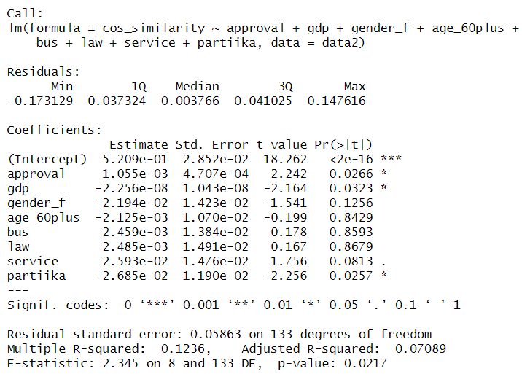

Appendix 3 “Descriptive statistics for the within-model for republicans”
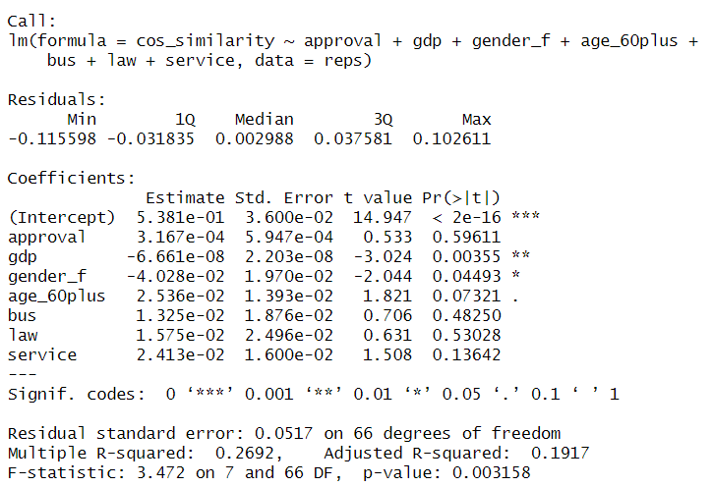

Appendix 4 “Descriptive statistics for the within-model for democrats”
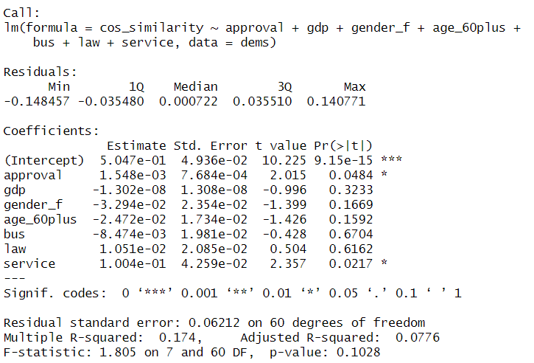

William H. Riker, Federalism : Origin, Operation, Significance (Little, Brown, 1964).
Sukhareva E.S. Variations of discursive strategies of gubernatorial electoral campaigns in the USA. Term paper [manuscript]. HSE University, Saint-Petersburg, 2024., p. 31
“State Preemption and Local Responses in the Pandemic | ACS,” June 22, 2020, https://www.acslaw.org/expertforum/state-preemption-and-local-responses-in-the-pandemic/., accessed May 10, 2025 Mike Shaw, “State Governments: Power during the Pandemic,” Wake Forest News (blog), May 28, 2020, https://news.wfu.edu/2020/05/28/state-governments-and-power-during-the-pandemic/., accessed May 10, 2025
“U.S. Constitution | Constitution Annotated | Congress.Gov | Library of Congress,” accessed May 15, 2025, https://constitution.congress.gov/constitution/.
Thad Kousser and Justin H. Phillips, The Power of American Governors: Winning on Budgets and Losing on Policy (Cambridge University Press, 2012)., p. 2
Margaret Robertson Ferguson, “Chief Executive Success in the Legislative Arena,” State Politics & Policy Quarterly 3, no. 2 (June 2003): 158–82, https://doi.org/10.1177/153244000300300203. Leonardo Baccini and Abel Brodeur, “Explaining Governors’ Response to the COVID-19 Pandemic in the United States,” American Politics Research 49, no. 2 (March 2021): 215–20, https://doi.org/10.1177/1532673X20973453.
Thad Kousser and Justin H. Phillips, The Power of American Governors: Winning on Budgets and Losing on Policy (Cambridge University Press, 2012)., p. 2
Jennifer M. Jensen, “Governors and Partisan Polarization in the Federal Arena,” Publius: The Journal of Federalism 47, no. 3 (2017): 314–41, https://doi.org/10.1093/publius/pjx035., p. 315
Maxim Gakh et al., “How Have States Used Executive Orders to Address Public Health?,” Journal of Public Health Management and Practice 25, no. 1 (February 2019): 78, https://doi.org/10.1097/PHH.0000000000000802.
Arnold F. Shober, “Governors Make the Grade: Growing Gubernatorial Influence in State Education Policy,” Peabody Journal of Education, November 1, 2012, https://www.tandfonline.com/doi/abs/10.1080/0161956X.2012.723494., p. 572
Maxim Gakh et al., “How Have States Used Executive Orders to Address Public Health?,” Journal of Public Health Management and Practice 25, no. 1 (February 2019): 78, https://doi.org/10.1097/PHH.0000000000000802.
Hallas, Laura, et al. "Variation in US states’ responses to COVID-19." University of Oxford (2021).
Ibid, p. 3
Charles D. Taylor, “Governors as Economic Problem Solvers: A Research Commentary,” Economic Development Quarterly 26, no. 3 (August 2012): 267–76, https://doi.org/10.1177/0891242412453114. Keith Boeckelman, “Governors, Economic Theory, and Development Policy,” Economic Development Quarterly : The Journal of American Economic Revitalization, Economic development quarterly : the journal of American economic revitalization. - Thousand Oaks, Calif. : SAGE Publ., ISSN 0891-2424, ZDB-ID 12650857. - Vol. 10.1996, 4, p. 342-351, 10, no. 4 (1996). Charles Barrilleaux and Michael Berkman, “Do Governors Matter? Budgeting Rules and the Politics of State Policymaking,” Political Research Quarterly 56, no. 4 (December 2003): 409–17, https://doi.org/10.1177/106591290305600403. George A. Krause and Benjamin F. Melusky, “Concentrated Powers: Unilateral Executive Authority and Fiscal Policymaking in the American States,” The Journal of Politics 74, no. 1 (January 2012): 98–112, https://doi.org/10.1017/S0022381611001149.
Thad Kousser and Justin H. Phillips, The Power of American Governors: Winning on Budgets and Losing on Policy (Cambridge University Press, 2012).
Ibid, p. 32
Margaret Robertson Ferguson, “Chief Executive Success in the Legislative Arena,” State Politics & Policy Quarterly 3, no. 2 (June 2003): 158–82, https://doi.org/10.1177/153244000300300203. Thad Kousser and Justin H. Phillips, “Who Blinks First? Legislative Patience and Bargaining with Governors,” Legislative Studies Quarterly 34, no. 1 (February 1, 2009): 55–86, https://doi.org/10.3162/036298009787500321. Susan Webb Yackee, “Executive Policymaking Influence via the Administrative Apparatus,” Public Administration Review, November 21, 2024, https://doi.org/10.1111/puar.13899. Robert J. McGrath, Jon C. Rogowski, and Josh M. Ryan, “Veto Override Requirements and Executive Success,” Political Science Research and Methods 6, no. 1 (January 2018): 153–79, https://doi.org/10.1017/psrm.2015.80.
Thad Kousser and Justin H. Phillips, The Power of American Governors: Winning on Budgets and Losing on Policy (Cambridge University Press, 2012)., p. 2
Ibid, p. 9
Robert E. Jr. Crew and Gregory R. Weiher, “Gubernatorial Popularity in Three States: A Preliminary Model,” The Social Science Journal 33, no. 1 (March 1, 1996): 39–54, https://doi.org/10.1016/S0362-3319(96)90004-X.
LEE SIGELMAN and NELSON C. DOMETRIUS, “GOVERNORS AS CHIEF ADMINISTRATORS: The Linkage Between Formal Powers and Informal Influence,” American Politics Quarterly 16, no. 2 (April 1, 1988): 157–70, https://doi.org/10.1177/004478088016002002.
Jeffrey E. Cohen and James D. King, “Relative Unemployment and Gubernatorial Popularity,” The Journal of Politics 66, no. 4 (November 2004): 1267–82, https://doi.org/10.1111/j.0022-3816.2004.00299.x.
Alan Rosenthal, The Best Job in Politics: Exploring How Governors Succeed as Policy Leaders (SAGE, 2012)., p. 115
Thad Kousser and Justin H. Phillips, The Power of American Governors: Winning on Budgets and Losing on Policy (Cambridge University Press, 2012)., p. 32
Octavio Amorim Neto, “The Puzzle of Party Discipline in Brazil,” Latin American Politics and Society 44, no. 1 (April 2002): 127–44, https://doi.org/10.1111/j.1548-2456.2002.tb00199.x. Scott Morgenstern and Javier Vázquez-D’Elía, “Electoral Laws, Parties, and Party Systems in Latin America,” Annual Review of Political Science 10, no. Volume 10, 2007 (June 15, 2007): 143–68, https://doi.org/10.1146/annurev.polisci.10.081205.094050.
Scott Mainwaring and Aníbal Pérez Liñán, “Party Discipline in the Brazilian Constitutional Congress,” Legislative Studies Quarterly 22, no. 4 (1997): 453–83, https://doi.org/10.2307/440339. Patricia Otero-Felipe and Leticia M Ruiz Rodríguez, “Party Discipline in Latin America: The Role of Party Ideology,” Political Studies Review 22, no. 3 (August 1, 2024): 608–26, https://doi.org/10.1177/14789299231176699.
Mikhail Filippov, “Riker and Federalism,” Constitutional Political Economy 16, no. 2 (June 1, 2005): 93–111, https://doi.org/10.1007/s10602-005-2230-x.
Terry D. Clark, Žilvinas Martinaitis, and Ramūnas Dilba, “Electoral Mandate and Party Cohesion: Does It Matter in Lithuania?,” Journal of Communist Studies and Transition Politics 24, no. 3 (September 2008): 317–37, https://doi.org/10.1080/13523270802267864., p. 334
Federico Ferrara, “Frogs, Mice and Mixed Electoral Institutions: Party Discipline in Italy’s XIV Chamber of Deputies1,” The Journal of Legislative Studies 10, no. 4 (December 21, 2004): 10–31, https://doi.org/10.1080/1357233042000322454.
Noah Dasanaike, “Businessperson Deputies and Party Cohesion: Evidence from the Russian State Duma,” Party Politics 28, no. 5 (September 2022): 879–88, https://doi.org/10.1177/13540688211025176., p. 9
Laurentiu Stefan, Sergiu Gherghina, and Mihail Chiru, “We All Agree That We Disagree Too Much: Attitudes of Romanian MPs towards Party Discipline,” East European Politics 28, no. 2 (June 2012): 180–92, https://doi.org/10.1080/13523279.2011.635649., p. 190
Lynda Erickson, “Might More Women Make a Difference? Gender, Party and Ideology among Canada’s Parliamentary Candidates,” Canadian Journal of Political Science 30, no. 4 (December 1997): 663–88, https://doi.org/10.1017/S0008423900016474.
Amanda Clayton and Pär Zetterberg, “Gender and Party Discipline: Evidence from Africa’s Emerging Party Systems,” American Political Science Review 115, no. 3 (August 2021): 869–84, https://doi.org/10.1017/S0003055421000368.
Michelle M. Taylor-Robinson and Roseanna Michelle Heath, “Do Women Legislators Have Different Policy Priorities than Their Male Colleagues?: A Critical Case Test,” Women & Politics 24, no. 4 (January 2003): 77–101, https://doi.org/10.1300/J014v24n04_04.
Csaba Nikolenyi, “The Adoption of Anti-Defection Laws in Parliamentary Democracies,” Election Law Journal: Rules, Politics, and Policy 15, no. 1 (March 2016): 96–108, https://doi.org/10.1089/elj.2015.0345., p. 106-107
Csaba Nikolenyi and Shaul R. and Shenhav, “The Constitutionalisation of Party Unity: The Origins of Anti-Defection Laws in India and Israel,” The Journal of Legislative Studies 21, no. 3 (July 3, 2015): 390–407, https://doi.org/10.1080/13572334.2015.1044229., p. 403
Edward Crowe, “Consensus and Structure in Legislative Norms: Party Discipline in the House of Commons,” The Journal of Politics 45, no. 4 (November 1983): 907–31, https://doi.org/10.2307/2130418., p. 929
James M. Snyder and Tim Groseclose, “Estimating Party Influence in Congressional Roll-Call Voting,” American Journal of Political Science 44, no. 2 (April 2000): 193, https://doi.org/10.2307/2669305. Timothy P. Nokken, “Dynamics of Congressional Loyalty: Party Defection and Roll-Call Behavior, 1947-97,” Legislative Studies Quarterly 25, no. 3 (August 2000): 417, https://doi.org/10.2307/440414. Edward B. Hasecke and Jason D. Mycoff, “Party Loyalty and Legislative Success: Are Loyal Majority Party Members More Successful in the U.S. House of Representatives?,” Political Research Quarterly 60, no. 4 (December 2007): 607–17, https://doi.org/10.1177/1065912907305754.
Kathryn Pearson, “Party Discipline in the U.S. House of Representatives” (Ann Arbor, MI: University of Michigan Press, 2015), https://doi.org/10.3998/mpub.4402299.
Keith Krehbiel, “Party Discipline and Measures of Partisanship,” American Journal of Political Science 44, no. 2 (April 2000): 212, https://doi.org/10.2307/2669306.
Allenna Leonard, “Viable System Model of Political Parties,” 2016, https://www.semanticscholar.org/paper/Viable-System-Model-of-Political-Parties-Leonard/35d527d0eea344b7aca9818ee23563b416e262ec. Micael Castanheira and Benoît S. Y. Crutzen, “Comparative Politics with Endogenous Intra-Party Discipline 1,” 2010, https://www.semanticscholar.org/paper/Comparative-Politics-with-Endogenous-Intra-Party-1-Castanheira-Crutzen/6eb3435940b8921441c34f0e7ba36f08a10221a2. Gary W. Cox, “Comparing Responsible Party Government in the United States and the United Kingdom,” The Journal of Politics 86, no. 1 (January 1, 2024): 67–78, https://doi.org/10.1086/726919.
Scott Ashworth and Ethan Bueno de Mesquita, “Endogenous Party Discipline with Variable Electoral and Legislative Institutions 1,” 2004, https://www.semanticscholar.org/paper/Endogenous-Party-Discipline-with-Variable-Electoral-Ashworth-Mesquita/76e26027468e80f038e04905a508044bf6667b76. Kathryn Pearson, “Party Discipline in the U.S. House of Representatives” (Ann Arbor, MI: University of Michigan Press, 2015), https://doi.org/10.3998/mpub.4402299. Nolan McCarty, Keith T. Poole, and Howard Rosenthal, “The Hunt for Party Discipline in Congress,” American Political Science Review 95, no. 3 (September 2001): 673–87, https://doi.org/10.1017/S0003055401003069.
Valdimer Orlando Key, American State Politics: An Introduction (Knopf, 1956)., p. 18
Anthony Sparacino, “The Democratic and Republican Governors Associations and the Nationalization of American Party Politics, 1961–1968,” Studies in American Political Development 35, no. 1 (April 2021): 76–103, https://doi.org/10.1017/S0898588X20000188. William M. Lunch and William M. Lunch, The Nationalization of American Politics (University of California Press, 1987).
Hedrick Smith, The Power Game: How Washington Works (Ballantine Books, 1989).
James Q. Wilson and John J. DiIulio, American Government: Institutions and Policies (D.C. Heath, 1995)., p. 180
Edward S. Greenberg and Benjamin I. Page, The Struggle for Democracy (Longman, 2003)., p. 269
Larry M. Bartels, “Partisanship and Voting Behavior, 1952-1996,” American Journal of Political Science 44, no. 1 (2000): 35–50, https://doi.org/10.2307/2669291., p. 35 Jones, Philip Edward. "Partisanship, Political Awareness, and Retrospective Evaluations, 1956–2016." Political Behavior 42, no. 4 (December 1, 2020): 1295–1317. https://doi.org/10.1007/s11109-019-09543-y.
Jennifer M. Jensen, “Governors and Partisan Polarization in the Federal Arena,” Publius: The Journal of Federalism 47, no. 3 (2017): 314–41, https://doi.org/10.1093/publius/pjx035., p. 4
Matthews, Donald. (1984). Legislative Recruitment and Legislative Careers. Legislative Studies Quarterly. 9. 547. 10.2307/439635., p. 554
Wayne L. Francis and Lawrence W. Kenny, Up the Political Ladder: Career Paths in US Politics (SAGE Publications, 2000).
Kathryn Pearson, Party Discipline in the U.S. House of Representatives, ed. Janet M. Box-Steffensmeier and David Canon (University of Michigan Press, 2015), https://doi.org/10.3998/mpub.4402299., p. 12
Matthews, Donald. (1984). Legislative Recruitment and Legislative Careers. Legislative Studies Quarterly. 9. 547. 10.2307/439635., p. 554
Jennifer M. Jensen, “Governors and Partisan Polarization in the Federal Arena,” Publius: The Journal of Federalism 47, no. 3 (2017): 314–41, https://doi.org/10.1093/publius/pjx035., p. 2
Ibid, p. 2
Sarah McCally Morehouse, The Governor as Party Leader : Campaigning and Governing (Ann Arbor : University of Michigan Press, 1998), http://archive.org/details/governoraspartyl0000more.
Jennifer M. Jensen, “Governors and Partisan Polarization in the Federal Arena,” Publius: The Journal of Federalism 47, no. 3 (2017): 314–41, https://doi.org/10.1093/publius/pjx035., p. 4
Heike Klüver and Iñaki Sagarzazu, “Setting the Agenda or Responding to Voters? Political Parties, Voters and Issue Attention,” West European Politics, March 3, 2016, https://www.tandfonline.com/doi/abs/10.1080/01402382.2015.1101295.
Andrew Crines and Tim Heppell, “Rhetorical Style and Issue Emphasis within the Conference Speeches of UKIP’s Nigel Farage 2010–2014,” British Politics 12, no. 2 (May 1, 2017): 231–49, https://doi.org/10.1057/bp.2016.2.
Chinwe RoseAnn Ezeifeka, “Critical Discourse Analysis of Interpersonal Meaning and Power Relations in Selected Inaugural Political Speeches in Nigeria,” UJAH: Unizik Journal of Arts and Humanities, January 1, 2014, https://www.academia.edu/105313062/Critical_Discourse_Analysis_of_Interpersonal_Meaning_and_Power_Relations_in_Selected_Inaugural_Political_Speeches_in_Nigeria.
Heike Klüver and Jae-Jae Spoon, “Who Responds? Voters, Parties and Issue Attention,” British Journal of Political Science 46, no. 3 (July 2016): 633–54, https://doi.org/10.1017/S0007123414000313. Markus Wagner and Thomas M. Meyer, “Which Issues Do Parties Emphasise? Salience Strategies and Party Organisation in Multiparty Systems,” West European Politics 37, no. 5 (September 3, 2014): 1019–45, https://doi.org/10.1080/01402382.2014.911483.
Heike Klüver and Iñaki Sagarzazu, “Setting the Agenda or Responding to Voters? Political Parties, Voters and Issue Attention,” West European Politics, March 3, 2016, https://www.tandfonline.com/doi/abs/10.1080/01402382.2015.1101295., p. 395
Chinwe RoseAnn Ezeifeka, “Critical Discourse Analysis of Interpersonal Meaning and Power Relations in Selected Inaugural Political Speeches in Nigeria,” UJAH: Unizik Journal of Arts and Humanities, January 1, 2014, https://www.academia.edu/105313062/Critical_Discourse_Analysis_of_Interpersonal_Meaning_and_Power_Relations_in_Selected_Inaugural_Political_Speeches_in_Nigeria., p. 46
“Issue Convergence in Presidential Campaigns,” ResearchGate, October 22, 2024, https://doi.org/10.1007/s11109-005-3077-6. Lee Sigelman and Emmett H. Buell, “Avoidance or Engagement? Issue Convergence in U.S. Presidential Campaigns, 1960–2000,” American Journal of Political Science 48, no. 4 (October 2004): 650–61, https://doi.org/10.1111/j.0092-5853.2004.00093.x. Ahmad Zirak Ghazani, “Study of Persuasive Strategies in Selected American Presidential Speeches,” International Journal of Humanities and Social Sciences, September 18, 2016, https://www.semanticscholar.org/paper/Study-of-Persuasive-Strategies-in-Selected-American-Ghazani/33799dacbe4574170ef6fa4a871d636999f550e1. Zhong Xiao-ya, “The Socio Pragmatic Functions of Inaugural Speech: A Critical Discourse Analysis,” Overseas English, 2014, https://www.semanticscholar.org/paper/The-Socio-Pragmatic-Functions-of-Inaugural-Speech%3A-Xiao-ya/3c1f7468162bb27694fd1641e13246f7497146a0.
James N. Druckman, Martin J. Kifer, and Michael Parkin, “Campaign Communications in U.S. Congressional Elections,” American Political Science Review 103, no. 3 (August 2009): 343–66, https://doi.org/10.1017/S0003055409990037. Patrick J. Egan, Partisan Priorities: How Issue Ownership Drives and Distorts American Politics (Cambridge: Cambridge University Press, 2013), https://doi.org/10.1017/CBO9781107337138. Tracy Sulkin, “Campaign Appeals and Legislative Action,” The Journal of Politics 71, no. 3 (July 2009): 1093–1108, https://doi.org/10.1017/S0022381609090902.
Daniel DiLeo, “Dynamic Representation in the United States: Effects of the Public Mood on Governors’ Agendas,” State and Local Government Review 29, no. 2 (March 1997): 98–109, https://doi.org/10.1177/0160323X9702900204. Daniel Coffey, “Measuring Gubernatorial Ideology: A Content Analysis of State of the State Speeches,” State Politics & Policy Quarterly 5, no. 1 (April 2005): 88–103, https://doi.org/10.1177/153244000500500105.
Hansen, Susan B. “‘Life Is Not Fair’: Governors’ Job Performance Ratings and State Economies.” Political Research Quarterly 52, no. 1 (March 1, 1999): 167–88. https://doi.org/10.1177/106591299905200107.
Curt Nichols, “Executive Behavior and the Influence of Religious Factors: Evidence from Gubernatorial State-of-the-State Addresses, 2000–2013,” Politics, Groups, and Identities, January 2, 2016, https://www.tandfonline.com/doi/abs/10.1080/21565503.2015.1050408.
Finn, P., & Furse, T. (2023). Exploring the 2022 US Midterms. Brianne Heidbreder and Katherine Felix Scheurer, “Gender and the Gubernatorial Agenda,” State and Local Government Review 45, no. 1 (March 2013): 3–13, https://doi.org/10.1177/0160323X12463945.
Shannon C. McGregor, Regina G. Lawrence, and Arielle Cardona, “Personalization, Gender, and Social Media: Gubernatorial Candidates’ Social Media Strategies,” Information, Communication & Society 20, no. 2 (February 2017): 264–83, https://doi.org/10.1080/1369118X.2016.1167228.
James D. King and Jeffrey E. Cohen, “What Determines a Governor’s Popularity?,” State Politics & Policy Quarterly 5, no. 3 (2005): 225–47, https://doi.org/10.1177/153244000500500302.
Alan I. Abramowitz and Steven Webster, “The Rise of Negative Partisanship and the Nationalization of U.S. Elections in the 21st Century,” Electoral Studies 41 (March 1, 2016): 12–22, https://doi.org/10.1016/j.electstud.2015.11.001. Larry M. Bartels, “Partisanship and Voting Behavior, 1952-1996,” American Journal of Political Science 44, no. 1 (2000): 35–50, https://doi.org/10.2307/2669291. Paul S. Herrnson and James M. Curry, “Issue Voting and Partisan Defections in Congressional Elections,” accessed November 28, 2024, https://onlinelibrary.wiley.com/doi/10.1111/j.1939-9162.2011.00014.x.
Sean Gailmard, “Accountability and Principal–Agent Theory,” in The Oxford Handbook of Public Accountability, ed. Mark Bovens, Robert Goodin, and Thomas Schillemans (Oxford University Press, 2014), 0, https://doi.org/10.1093/oxfordhb/9780199641253.013.0016., p. 2
Ibid, p. 4
Paul Light, The President’s Agenda: Domestic Policy Choice from Kennedy to Clinton (JHU Press, 1999).
E. Schattschneider, Party Government: American Government in Action (New York: Routledge, 2017), https://doi.org/10.4324/9781315126050.
David R. Jones and M. McDermott, “The Responsible Party Government Model in House and Senate Elections,” American Journal of Political Science 48 (2004): 1–12, https://doi.org/10.1111/J.0092-5853.2004.00052.X. K. Leyden and Stephen A. Borrelli, “The Effect of State Economic Conditions on Gubernatorial Elections: Does Unified Government Make a Difference?,” Political Research Quarterly 48 (1995): 275–90, https://doi.org/10.1177/106591299504800203.
Alberto Francesco Alesina and Howard Rosenthal, “A Theory of Divided Government,” Scholarly Articles, Scholarly Articles, 1996, https://ideas.repec.org//p/hrv/faseco/34222831.html.
K. Leyden and Stephen A. Borrelli, “The Effect of State Economic Conditions on Gubernatorial Elections: Does Unified Government Make a Difference?,” Political Research Quarterly 48 (1995): 275–90, https://doi.org/10.1177/106591299504800203.
Wallace E. Oates, “On The Evolution of Fiscal Federalism: Theory and Institutions,” National Tax Journal 61, no. 2 (June 2008): 313–34, https://doi.org/10.17310/ntj.2008.2.08.
Wallace E. Oates, “Toward A Second-Generation Theory of Fiscal Federalism,” International Tax and Public Finance 12, no. 4 (August 1, 2005): 349–73, https://doi.org/10.1007/s10797-005-1619-9., p. 356
Margaret R. Ferguson and Jay Barth, “Governors in the Legislative Arena: The Importance of Personality in Shaping Success,” Political Psychology 23, no. 4 (2002): 787.
Matthew M. Singer, “Dynamics of Gubernatorial Approval: Evidence from a New Database,” State Politics & Policy Quarterly 23, no. 3 (September 2023): 306–26, https://doi.org/10.1017/spq.2023.11., p. 306 Thad Kousser and Justin H. Phillips, The Power of American Governors: Winning on Budgets and Losing on Policy (Cambridge University Press, 2012).
Wallace E. Oates, “On The Evolution of Fiscal Federalism: Theory and Institutions,” National Tax Journal 61, no. 2 (June 2008): 313–34, https://doi.org/10.17310/ntj.2008.2.08.
Ian Budge and Michael Laver, “Office Seeking and Policy Pursuit in Coalition Theory,” Legislative Studies Quarterly 11, no. 4 (1986): 485–506, https://doi.org/10.2307/439930., p. 486 William H. Riker, The Theory of Political Coalitions (Yale University Press, 1962).
David R. Mayhew, Congress: The Electoral Connection (Yale University Press, 1974)., p. 52
Mark Bovens, Robert E. Goodin, and Thomas Schillemans, The Oxford Handbook of Public Accountability (OUP Oxford, 2014)., Chapter 6
Scott Ashworth, “Electoral Accountability: Recent Theoretical and Empirical Work,” Annual Review of Political Science 15, no. Volume 15, 2012 (June 15, 2012): 183–201, https://doi.org/10.1146/annurev-polisci-031710-103823., p. 199
Robert D. Putnam, The Comparative Study of Political Elites (Englewood Cliffs, N.J. : Prentice-Hall, 1976), http://archive.org/details/comparativestudy00putn.
Matt Grossmann and David A. Hopkins, Asymmetric Politics: Ideological Republicans and Group Interest Democrats (Oxford University Press, 2016)., p. 72
Sarah Ferris Grayer Annie, “Hill Democrats Say Their Warnings about the Party’s Shortfalls on the Border Were Ignored | CNN Politics,” CNN, November 8, 2024, https://www.cnn.com/2024/11/08/politics/hill-democrats-border-warning., accessed May 8, 2025 “Democrats Are Trying to Work out What Went Wrong. On the Left a Consensus Is Forming,” The Independent, November 11, 2024, https://www.independent.co.uk/news/world/americas/us-politics/democrats-kamala-harris-bernie-sanders-elections-b2644773.html., accessed March 24, 2025
Matt Grossmann and David A. Hopkins, Asymmetric Politics: Ideological Republicans and Group Interest Democrats (Oxford University Press, 2016)., p. 72
Ibid, p. 74
“Multiple Linear Regression (MLR): Definition, Formula, and Example,” Investopedia, accessed May 10, 2025, https://www.investopedia.com/terms/m/mlr.asp.
GitHub. "Sots/Speeches_raw at Master · Leops95/Sots." Accessed May 10, 2024. https://github.com/leops95/sots/tree/master/speeches_raw.
Prabhakaran, Selva. "Cosine Similarity - Understanding the Math and How It Works? (With Python)." Machine Learning Plus (blog), October 22, 2018., Accessed May 3, 2024 https://www.machinelearningplus.com/nlp/cosine-similarity/.
Matthew Singer, “State Executive Approval Dataset (SEAD) Version 1” (Harvard Dataverse, January 31, 2023), https://doi.org/10.7910/DVN/I6VZ9Y., accessed December 29, 2024
“U.S. Bureau of Economic Analysis (BEA),” accessed December 30, 2024, https://www.bea.gov/.
“States,” Ballotpedia, accessed December 22, 2024, https://ballotpedia.org/States.
“Front Page,” National Governors Association, accessed December 30, 2024, https://www.nga.org/.
Joel D. Aberbach, Robert D. Putnam, and Bert A. Rockman, Bureaucrats and Politicians in Western Democracies (Harvard University Press, 1981)., p. 256
“Oregon,” National Governors Association (blog), accessed May 10, 2025, https://www.nga.org/former-governors/oregon/.
“Post - Newsroom,” accessed May 10, 2025, https://apps.oregon.gov/oregon-newsroom/OR/GOV/Posts/Post/governor-kate-brown-issues-statement-after-adjournment-of-bipartisan-special-session-20785.
Daniel Wenger, “Advice for Progressives from America’s Radical Feminist Governor,” The New Yorker, February 2, 2017, https://www.newyorker.com/news/news-desk/advice-for-progressives-from-americas-radical-feminist-governor., accessed May 10, 2025
“Gov. Perry Backs Resolution Affirming Texas’ Sovereignty under 10th Amendment. Love It or Hate It? Leave Your Comments.,” https://www.kltv.com, April 15, 2009, https://www.kltv.com/story/10182924/gov-perry-backs-resolution-affirming-texas-sovereignty-under-10th-amendment-love-it-or-hate-it-leave-your-comments., accessed May 3, 2025.
Chris Good, “Gov. Perry Asserts Texan Sovereignty,” The Atlantic (blog), April 14, 2009, https://www.theatlantic.com/politics/archive/2009/04/gov-perry-asserts-texan-sovereignty/13094/., accessed May 4, 2025 “Perry Says No to Texas Secession,” POLITICO, November 13, 2012, https://www.politico.com/story/2012/11/perry-says-no-to-texas-secession-083751., accessed May 4, 2025
“Governor Abbott Proclaims March 2, 2022 As Texas Independence Day,” accessed May 9, 2025, https://gov.texas.gov/news/post/governor-abbott-issues-proclamation-for-texas-independence-day-in-2022.
“Texas Governor Greg Abbott: ‘I Just Signed a Resolution Asserting Texas Sovereignty under the 10th Amendment over All Powers Not Granted to the Federal Government by the US Constitution.’ – Investment Watch Blog,” June 15, 2021, https://www.investmentwatchblog.com/texas-governor-greg-abbott-i-just-signed-a-resolution-asserting-texas-sovereignty-under-the-10th-amendment-over-all-powers-not-granted-to-the-federal-government-by-the-us-constitution/. accessed May 10, 2025
Eric Lopez, Marcus Stadelmann, and Robert E. Sterken Jr, Uncovering Texas Politics in the 21st Century (UT Tyler Press, 2020)., p. 16
Ibid, p. 16
“LRL | Legislative Information | Governors of Texas, 1846-Present,” October 19, 2004, https://web.archive.org/web/20041019141712/http://www.lrl.state.tx.us/legis/leaders/govbio.html., accessed May 10, 2025
Blaise Gainey, “Texas Republicans Divided: Conservative Factions Battle for House Speaker Role,” KUT Radio, Austin’s NPR Station, December 18, 2024, https://www.kut.org/politics/2024-12-18/house-speaker-cook-burrows-abbott-vouchers-texas-legislature., accessed May 10, 2025
Lotte Hargrave and Tone Langengen, “The Gendered Debate: Do Men and Women Communicate Differently in the House of Commons?,” Politics & Gender 17, no. 4 (December 2021): 580–606, https://doi.org/10.1017/S1743923X20000100.
Dragana Lenard, Gender Differences in Congressional Speeches (Ethics International Press, 2023). “Gender Gap Public Opinion,” accessed May 12, 2025, https://cawp.rutgers.edu/gender-gap-public-opinion.
Angus Campbell et al., The American Voter (University of Chicago Press, 1976). M. Kent Jennings et al., “Youth-Parent Socialization Panel Study, 1965-1997: Four Waves Combined” (Inter-university Consortium for Political and Social Research, November 4, 2005), https://doi.org/10.3886/ICPSR04037.v1.
Ilse Cornelis et al., “Age Differences in Conservatism: Evidence on the Mediating Effects of Personality and Cognitive Style,” Journal of Personality 77, no. 1 (February 2009): 51–87, https://doi.org/10.1111/j.1467-6494.2008.00538.x. Nicholas L. Danigelis, Melissa Hardy, and Stephen J. Cutler, “Population Aging, Intracohort Aging, and Sociopolitical Attitudes,” American Sociological Review, October 1, 2007, https://doi.org/10.1177/000312240707200508.
Johnathan Peterson, Kevin Smith, and John Hibbing, “Do People Really Become More Conservative as They Age?,” Department of Political Science: Faculty Publications, January 1, 2019, https://digitalcommons.unl.edu/poliscifacpub/112., p. 600
Jennifer Rubin, “Opinion | Trump’s Rhetoric Turns off Even Republicans,” The Washington Post, June 2, 2020, https://www.washingtonpost.com/opinions/2020/06/02/you-wonder-why-trump-hasnt-shouldnt-speak/., accessed May 10, 2025 “The Post-Trump Identity Crisis That’s Fracturing the GOP,” PBS News, February 5, 2021, https://www.pbs.org/newshour/politics/the-post-trump-identity-crisis-thats-fracturing-the-gop., accessed May 10, 2025 Michael C. Bender, “Republican Governors Distance Themselves From Trump, Drawing His Ire,” WSJ, November 20, 2021, https://www.wsj.com/politics/policy/republican-governors-distance-themselves-from-trump-drawing-his-ire-11637357756., accessed May 10, 2025

